GYANCODE : AN INTERACTIVE CODE LEARNING & ASSESSMENT SYSTEM

A Project Dissertation
Submitted in Partial Fulfillment of the Requirements for the Degree of
BACHELOR OF SCIENCE IN INFORMATION TECHNOLOGY

By
Paragkumar Kailash Suthar TRITG525051
Under the esteemed guidance of PROF. SHAHID PERVEZ
(FACULTY OF DEPARTMENT OF INFORMATION TECHNOLOGY)


DEPARTMENT OF INFORMATION TECHNOLOGY
K.P.B. HINDUJA COLLEGE OF COMMERCE
(Affiliated to University of Mumbai)

MUMBAI - 400004 MAHARASHTRA 2025 - 2026

K.P.B. HINDUJA COLLEGE OF COMMERCE
(Affiliated to University of Mumbai)
MUMBAI - MAHARASHTRA - 400004
DEPARTMENT OF INFORMATION TECHNOLOGY

PROFORMA FOR THE APPROVAL PROJECT PROPOSAL
(Note: All entries of the proforma of approval should be filled up with appropriate and complete information. Incomplete proforma of approval in any respect will be summarily rejected.)
PNR No.: ........................ Roll no: ……………………

- Name of the Student

- Title of the Project

- Name of the Guide

- Teaching experience of the Guide

- Is this your first submission? Yes No

Signature of the Student Signature of the Guide

Date: …………………… Date: ……………………

Signature of the Coordinator

Date: ……………………



CERTIFICATE

This is to certify that the project entitled “GyanCode Platform: An Interactive Code Learning & Assessment System” is a Bonafide work submitted by Mr. Paragkumar Kailash Suthar Seat No: TRITG525051 in partial fulfillment of the requirements for the award of the degree of Bachelor of Science in Information Technology. This project work has been carried out under my guidance and supervision.

Prof. Shahid Pervez Dr. Ansari Md. Nasir

Internal Guide Course Coordinator

Internal Examiner External Examiner

Date: College Seal

ABSTRACT
The project, "GyanCode Platform," addresses the inefficiencies in traditional programming education within IT courses. It aims to bridge the gap between educators and students by introducing an interactive digital platform for learning and assessment. The system provides students with an integrated code editor and real-time execution for various programming languages, while offering AI-powered feedback using the Google Gemini API to guide them. For educators, it streamlines the assignment creation, submission, and assessment process, reducing manual workload. The platform features role-based dashboards, automated progress tracking, and a system for issuing digital certificates. The primary objective is to create a more engaging, efficient, and dynamic learning environment, enhancing practical programming skills. The scope of the project covers the entire assignment lifecycle, from creation to automated validation and progress monitoring.

ACKNOWLEDGEMENT
I would like to express my deepest gratitude and sincere thanks to my project guide,

Mr. Shahid Pervez, for their invaluable guidance, constant encouragement, and insightful suggestions throughout the development of this project. Their expertise and support were instrumental in navigating the complexities of the project and bringing it to a successful completion.
I am also grateful to the Head of the Department of Information Technology,

Dr. Nasir Ansari, and the entire faculty for providing the necessary infrastructure and fostering a learning environment that was conducive to research and development. I extend my thanks to the Principal and management of K.P.B. Hinduja College of Commerce for their continuous support. I would also like to thank my parents and family for their unwavering love, encouragement,
and support throughout my academic journey. Their blessings have always been a source of strength for me.
Finally, I would like to acknowledge my friends and classmates who have provided their help and constructive feedback during various stages of this project. Their companionship and support have made this journey more enjoyable.

Paragkumar Kailash Suthar TRITG525051

DECLARATION

I hereby declare that the project entitled, “GyanCode Platform: An Interactive Code Learning & Assessment System” done at K.P.B. Hinduja College of Commerce, Mumbai, has not been in any case duplicated to submit to any other university for the award of any degree. To the best of my knowledge other than me, no one has submitted to any other university.
The project is done in partial fulfillment of the requirements for the award of degree of BACHELOR OF SCIENCE (INFORMATION TECHNOLOGY) to be submitted as final semester project as part of our curriculum.
Signature

……………………………

Paragkumar Kailash Suthar TRITG525051

Table Of Contents

Sr. No. | Topic | Page No.
Chapter 1 | Introduction | 1-4
1.1 | Background | 1
1.2 | Objectives | 1
1.3 | Purpose | 2
1.4 | Scope | 1
1.5 | Applicability | 3
1.6 | Achievements | 3
1.7 | Organization of report | 4
Chapter 2 | Survey of Technology | 5-14
2.1 | Overview of existing technology | 5
2.2 | Details of all related technologies | 7
2.3 | Technology available in chosen area | 11
2.4 | Student selected this technology | 13
Chapter 3 | Requirement and Analysis | 15-31
3.1 | Problem Definition | 15
3.2 | Requirement Specification | 16
3.2.1 | Functional Requirements | 16
3.2.2 | Non-functional Requirements | 18
3.3 | Planning and Scheduling | 20
3.3.1 | Gantt Chart | 20
3.4 | Software and Hardware Requirements | 21
3.4.1 | Software Requirements | 21
3.4.2 | Hardware Requirements | 22
3.5 | Feasibility Study | 23
3.5.1 | Technical Feasibility | 23
3.5.2 | Economic Feasibility | 24
3.5.3 | Operational Feasibility | 24
3.6 | Fact Finding Technique | 25
3.6.1 | Observation | 26
3.6.2 | Record Review | 27
3.6.3 | Questionnaires | 28
3.6.4 | Interview | 30
Chapter 4 | System Design | 32-59
4.1 | Design Diagrams | 32
4.1.1 | E-R Diagram | 32
4.1.2 | Class Diagram | 34
4.1.3 | Use Case Diagram | 36
4.1.4 | Sequence Diagram | 38
4.1.5 | Activity Diagram | 41
4.2 | Module Design | 44
4.2.1 | Module Names with description | 44
4.2.2 | Module Functionality | 46
4.3 | Schema Design | 48
4.3.1 | Database Design | 48
4.4 | Data Integrity and Constraints | 52
4.4.1 | Data Integrity | 52
4.4.2 | Data Constraints | 53
4.5 | User Interface Design | 54
4.5.1 | Design Consideration | 55
4.5.2 | UI/UX Design | 56
4.6 | Security Issues | 57
4.6.1 | Security Issues related to project | 57
4.6.2 | Security Policy and Plan | 58

Chapter 1: Introduction

Background

In the rapidly evolving field of Information Technology, practical programming proficiency is a cornerstone of a student's education. However, educational institutions, particularly those offering B.Sc. (IT) programs often face significant challenges in delivering and assessing programming assignments effectively. The conventional methods rely on a manual workflow where educators distribute assignments, students write code on local machines, and submissions are handled via email or physical copies. This process is fraught with inefficiencies, including delays in providing feedback, a heavy manual grading burden on faculty, and a disjointed learning experience for students who struggle with setting up complex development environments. This gap between theoretical knowledge and practical application hinders the development of robust coding skills and can diminish student engagement.

Objectives

The primary objective of the GyanCode Platform is to develop a centralized, interactive system that bridges the learning and assessment gap in programming education. The project aims to achieve the following key goals:
    - To design and implement a web-based platform with distinct interfaces for students and educators.
    - To provide an integrated, browser-based code editor that supports multiple programming languages like C, C++, Python, Java, and JavaScript.
    - To enable real-time code execution and provide immediate feedback on syntax and runtime errors.
    - To automate the code validation process by comparing student output against predefined expected outputs.
    - To leverage an AI model to generate intelligent, actionable hints for incorrect submissions, guiding students toward the correct solution without revealing it directly.
    - To create a streamlined workflow for educators to create, manage, and track assignments.

    - To develop a comprehensive dashboard for educators to monitor class-wide and individual student progress.
    - To implement an automated system for generating and issuing digital certificates upon the completion of learning milestones.

Purpose

The purpose of this project is to address the inherent limitations of the traditional assignment management system. The existing methods lack immediate feedback, which is critical for a fast-paced learning loop in programming. They also place a significant administrative and assessment load on educators, leading to potential inconsistencies in feedback quality and long turnaround times. Students often face technical barriers in just setting up their local coding environments, which can cause frustration and detract from the learning objectives. The GyanCode Platform is designed to eliminate these bottlenecks by providing a unified, accessible, and automated solution. Its purpose is to foster a more engaging and efficient educational ecosystem where students can practice coding seamlessly and educators can focus on teaching and mentoring rather than on manual, repetitive assessment tasks.

Scope

The scope of the GyanCode Platform encompasses the end-to-end lifecycle of programming assignments. It includes secure user registration and authentication for two distinct roles: Student and Educator. For students, the scope covers a personalized dashboard, the ability to select assignments based on academic year and proficiency level (Beginner, Intermediate, Professional), an integrated code editor for writing and running code, and a system for submitting assignments for validation. For educators, the scope includes a dashboard to manage assignments, create problem statements with expected inputs/outputs, monitor student. progress, view submission details, and issue digital certificates. The AI integration for providing hints on incorrect code is a core component within the project's scope. The system will support major programming languages relevant to the B.Sc. (IT) curriculum. However, the scope does not extend to full-fledged IDE features like debugging tools or collaborative coding in real-time.

Applicability

The GyanCode Platform has direct and wide-ranging applicability in academic and training environments. Its primary area of application is within colleges and universities offering undergraduate courses in Information Technology, Computer Science, and related fields. It can be seamlessly integrated into the curriculum to manage lab assignments, practical exams, and homework. Beyond formal education, the platform is also applicable in coding bootcamps, corporate training programs for new software development hires, and online learning platforms that require a practical component for their programming courses. Its scalable architecture allows it to be adapted for different class sizes and a variety of programming languages, making it a versatile tool for any institution focused on enhancing practical coding skills.

Achievements

The successful implementation of the GyanCode Platform will represent a significant achievement in modernizing programming education. The key contribution of this project is the creation of a unified, self-contained learning ecosystem that enhances the educational experience for both students and educators. It achieves a highly efficient, automated assessment workflow, drastically reducing the time and effort required for grading assignments. For students, the project achieves a more interactive and responsive learning process through instant code execution and intelligent, AI-driven feedback, thereby fostering self-paced learning and improving coding proficiency. Furthermore, the gamified points system and the issuance of digital certificates serve as motivational tools, encouraging continuous learning and skill development.

Organization of Report

This project report is structured into several chapters to provide a clear and comprehensive overview of the work undertaken.
    - Chapter 1 provides an introduction to the project, outlining the background, objectives, purpose, scope, applicability, and key achievements.
    - Chapter 2 presents a survey of the technologies used in the project, discussing existing systems and justifying the choice of the technology stack.
    - Chapter 3 details the requirement and analysis phase, including the problem definition, functional and non-functional requirements, project planning, and feasibility studies.
    - Chapter 4 describes the system design, presenting various design diagrams, module design, database schema, and considerations for the user interface and security.

Chapter 2: Survey of Technology

Overview of Existing Technology

The domain of educational technology, particularly for programming, is well-established and features a wide array of tools and platforms. These technologies can be broadly categorized into Learning Management Systems (LMS), online code editors and Integrated Development Environments (IDEs), and automated assessment tools. Understanding this landscape is crucial to contextualize the development of the GyanCode Platform and to identify the specific gaps it aims to fill.
Traditional Learning Management Systems like Moodle, Canvas, and Blackboard are widely used in educational institutions for course management. They excel at handling administrative tasks such as distributing course materials, managing enrollments, facilitating discussions, and collecting assignments. However, these platforms are general-purpose and typically lack specialized features for programming education. While a student can upload a
.java or .py file as an assignment, the LMS itself cannot compile, execute, or automatically grade the code. This means educators must still manually download, set up, run, and evaluate each submission, which is the primary bottleneck this project seeks to address.
In parallel, the rise of cloud computing has led to the proliferation of online IDEs and code editors. Platforms such as Replit, Glitch, and GitHub Codespaces provide fully functional development environments directly in the browser. They eliminate the need for students to install and configure complex toolchains on their local machines, thereby lowering the barrier to entry. These platforms are excellent for writing and running code, and some even offer collaborative features. However, they are primarily development tools rather than educational platforms. They do not inherently include features for structured assignment management, automated grading based on specific I/O test cases, or progress tracking in an academic context. An educator might use Replit to host a project, but they would still need a separate system to manage the assessment workflow.

A third category consists of competitive programming and automated assessment platforms like HackerRank, LeetCode, and CodeSignal. These systems are highly specialized in automated code evaluation. They present users with a programming problem and an online editor, and they run the submitted code against a series of hidden test cases to determine its correctness and efficiency. While these platforms are extremely effective for assessment and practice, their focus is often on algorithmic challenges and technical interviews rather than on a structured, curriculum-based learning path. They are less suited for managing a classroom environment, tracking syllabus-specific progress, or providing the kind of guided, AI-driven feedback that is a core feature of the GyanCode Platform.
The GyanCode Platform is positioned at the intersection of these three categories. It aims to combine the classroom and assignment management features of an LMS, the accessibility of an online IDE, and the robust automated assessment capabilities of a competitive programming platform, while also introducing a novel AI-powered feedback mechanism to create a holistic educational tool tailored specifically for academic programming courses.

Details of Related Technologies

The technology stack for the GyanCode Platform was carefully selected to create a modern, scalable, and responsive web application. The architecture is based on a JavaScript ecosystem, leveraging its versatility across both frontend and backend development. The following sections detail the key technologies employed in this project.

Frontend (Web Application)

React: React, developed by Facebook, is a declarative and component-based JavaScript library for building user interfaces. It was chosen as the frontend framework due to its efficiency in rendering dynamic content and its strong community support. React's core concept is the Virtual DOM, an in-memory representation of the actual DOM. When the application's state changes, React updates the Virtual DOM first, calculates the most efficient difference (diffing), and then applies only the necessary changes to the real DOM. This process significantly improves performance, which is critical for an interactive application like a code editor and a real-time progress dashboard. Its component-based architecture allows for the creation of reusable UI elements (e.g., buttons, dashboards, code editors), making the codebase modular, easier to maintain, and scalable.
Tailwind CSS: For styling, Tailwind CSS was chosen over traditional CSS frameworks like Bootstrap. Tailwind is a utility-first CSS framework that provides low-level utility classes to build custom designs directly within the HTML. Instead of pre-styled components (like
.btn-primary), developers use classes like bg-blue-500, hover:bg-blue-700, text-white, font-bold, and py-2 to compose unique designs without writing custom CSS. This approach provides immense flexibility, prevents the proliferation of custom CSS files, and ensures a consistent design language throughout the application. It is particularly effective for creating a responsive design that works seamlessly across desktops, tablets, and mobile devices, which is a key requirement for the platform's accessibility.

Chart.js: To visualize student progress, Chart.js was integrated into the platform. It is a simple yet flexible open-source JavaScript library for creating various types of charts (e.g., bar, line, doughnut). On the student and educator dashboards, Chart.js is used to render intuitive visualizations of data such as assignments completed, points earned, and performance across different programming languages. These visual representations make it easier for users to quickly grasp performance trends and progress metrics, enhancing the overall user experience of the tracking and monitoring features.

Backend (API & Compiler Execution)

Node.js with Express.js: The backend of the GyanCode Platform is built using Node.js, a JavaScript runtime environment that allows server-side execution of JavaScript code. Node.js operates on an event-driven, non-blocking I/O model, which makes it lightweight and efficient for handling concurrent requests. This is particularly important for our application, which needs to handle numerous code execution and validation requests from multiple students simultaneously.
Express.js is a minimal and flexible web application framework for Node.js. It provides a robust set of features for building web and mobile applications, simplifying the process of creating APIs. In this project, Express.js is used to define the server's RESTful API endpoints, such as /api/execute for running code and /api/validate-submission for grading assignments. It manages the routing, handles HTTP requests and responses, and integrates with middleware for tasks like parsing request bodies. The core function of the backend is to securely execute untrusted student code. This is achieved using Node.js's built-in child_process module, which allows the server to spawn sandboxed child processes to compile and run the code for different languages (e.g., using gcc for C/C++, python for Python, node for JavaScript). This isolates the execution from the main server process, providing a layer of security.

Database & Authentication

Google Firebase: Firebase, a platform developed by Google, was chosen as the backend-as-a-service (BaaS) solution. It provides a suite of tools that significantly accelerate development, including a database, authentication services, and hosting.
Firebase Authentication: This service provides a secure and easy-to-implement authentication system. It supports various sign-in methods, including email/password, and handles the entire authentication lifecycle, from user registration to session management. For the GyanCode Platform, it is used to manage secure sign-up and login for both Student and Educator roles, ensuring that only authenticated and authorized users can access their respective dashboards and functionalities.
Firestore: Firestore is a flexible, scalable NoSQL cloud database for mobile, web, and server development from Firebase and Google Cloud. Its data model consists of collections and documents, which is well-suited for storing the varied and semi-structured data of our application, such as user profiles, assignment details (problem statements, languages, expected I/O), student submissions, and progress tracking data. One of Firestore's key features is its real-time data synchronization. Any connected client subscribed to a document or collection will automatically receive updates whenever the data changes. This is invaluable for features like the educator's progress monitoring dashboard, which can reflect student completions in real time.
Firebase Hosting: The frontend of the application, built with React, is deployed using Firebase Hosting. It provides fast and secure hosting for web apps with a single command. It delivers content via a global content delivery network (CDN), ensuring low latency for users worldwide.

Artificial Intelligence

Google Gemini API: The core innovation of this platform lies in its AI-powered feedback system, which is powered by the Google Gemini API. Gemini is a family of powerful, multimodal large language models (LLMs) developed by Google AI. When a student's code produces an output that does not match the expected output, the backend sends a carefully crafted prompt to the Gemini API. This prompt includes the student's code, the expected output, and the actual output generated. The API is instructed to analyze these three pieces of information and generate a concise, helpful hint that guides the student toward identifying and fixing the error without providing the direct solution. This capability transforms the platform from a simple pass/fail validator into a dynamic learning tool that actively assists in the educational process.

Technology in Chosen Area

The selection of a technology stack involves evaluating various alternatives to ensure the chosen tools are best suited for the project's specific requirements. This section provides a comparative study of the technologies selected for the GyanCode Platform against other popular options in their respective domains.

Frontend Framework: React vs. Angular vs. Vue.js

In the realm of frontend development, the three most prominent frameworks are React, Angular, and Vue.js. Angular, developed by Google, is a full-fledged Model-View-Controller (MVC) framework. It is highly opinionated, meaning it prescribes a specific structure for applications, and uses TypeScript, a superset of JavaScript. While Angular is powerful for large enterprise applications, its steep learning curve and rigidity were considered less suitable for the rapid development cycle of this project.

Vue.js is often seen as a middle ground between React and Angular. It is known for its progressive adoption model and approachability. While Vue is an excellent framework, React boasts a larger ecosystem, a vast collection of third-party libraries, and a larger developer community, which translates to better support and more available resources. For a project requiring specialized components like a sophisticated code editor and data visualizations, React's extensive ecosystem was a significant advantage. Furthermore, React's focus on being a library for UI development provides more flexibility, allowing developers to choose other libraries for state management and routing as needed.

Backend Technology: Node.js vs. Python (Django/Flask) vs. Java (Spring)

For the backend, several technologies were considered. Python, with frameworks like Django and Flask, is a strong contender, especially known for its clean syntax and extensive libraries for data science and AI. Django is a high-level "batteries-included" framework, while Flask is a micro-framework offering more flexibility. Java with the Spring framework is another robust choice, widely used in enterprise environments for building highly scalable and secure applications.
However, Node.js was chosen for several key reasons. Firstly, its non-blocking, event-driven architecture is particularly well-suited for I/O-heavy operations like handling API requests and managing the child processes for code execution. Secondly, using JavaScript on both the frontend and backend (a "full-stack JavaScript" approach) creates synergy, allowing for code reuse and a more streamlined development process with a single language. This consistency simplifies the toolchain and reduces the cognitive load on the developer. While Python's AI libraries are excellent, the core AI functionality of this project is accessed via the Gemini REST API, making the backend's native language less critical for that specific feature.

Database: Firebase (NoSQL) vs. Relational Databases (MySQL/PostgreSQL)

The choice of database was between a NoSQL model, as offered by Firebase Firestore, and a traditional relational (SQL) model, such as MySQL or PostgreSQL. Relational databases enforce a rigid schema with tables, rows, and columns, and are excellent for structured data with complex relationships.
A NoSQL database like Firestore was selected because its flexible, document-based data model is better suited to the application's needs. User data, assignment content, and progress logs can evolve, and a schema-less structure accommodates these changes easily. More importantly, Firebase's real-time capabilities are a defining factor. The ability to push data updates to clients in real time is a complex feature to build from scratch with a traditional SQL database, but it is a core, out-of-the-box feature of Firestore. This is essential for creating a dynamic user experience, especially for the educator's live progress monitoring dashboard. The integrated authentication and hosting services provided by the Firebase suite also offered a significant advantage in terms of development speed and simplified infrastructure management.

Student Selected Technology

The final technology stack for the GyanCode Platform was chosen after a careful analysis of the project's objectives and a comparative study of available technologies. Each component of the stack was selected to synergistically contribute to the platform's goals of creating an interactive, efficient, and scalable educational tool. The decision was driven by a philosophy of leveraging a modern, cohesive, and developer-friendly ecosystem.
The choice of a full-stack JavaScript environment, with React for the frontend and Node.js for the backend, was a strategic decision. This approach unifies the development process under a single language, which is not only efficient but also aligns with current industry trends. React was specifically selected for its component-based architecture and performance-oriented Virtual DOM, which are ideal for building the complex, interactive user interfaces required for the code editor and dashboards. Its vast ecosystem provided ready access to libraries like Chart.js for data visualization, accelerating development.

On the backend, Node.js's asynchronous, non-blocking nature is perfectly suited to the primary task of handling numerous concurrent requests for code execution. The use of the child_process module provides a secure and effective way to run multi-language code in isolated environments. The Express.js framework offers the necessary tools to build a robust API without unnecessary overhead, keeping the backend lightweight and focused.
Google Firebase was a cornerstone of the selected architecture. The decision to use Firebase was based on its powerful backend-as-a-service (BaaS) offerings, which dramatically reduce development time and complexity. Firebase Authentication provides a secure, production-ready user management system out of the box. The Firestore database was chosen for its flexible NoSQL data model and, most importantly, its real-time capabilities, which are central to the platform's dynamic progress-tracking features. Finally, Firebase Hosting simplifies the deployment process to a single command, with the added benefits of a global CDN.
The integration of the Google Gemini API is the project's key technological differentiator. While other platforms offer automated grading, the use of a state-of-the-art large language model to provide intelligent, contextual feedback is a novel approach. This technology was chosen because it elevates the platform beyond a simple assessment tool, turning it into an interactive tutor that actively helps students learn from their mistakes. The Gemini API's advanced reasoning capabilities are essential for analyzing code and generating high-quality, educational hints.
In conclusion, the selected technology stack represents a cohesive and powerful combination of tools. Each technology was chosen for its specific strengths and its ability to directly address the core requirements of the GyanCode Platform, from its interactive UI and real-time features to its secure code execution and intelligent AI feedback system.

Chapter 3: Requirement and Analysis

Problem Definition

The core problem addressed by this project is the operational inefficiency and pedagogical gap inherent in the traditional methods of managing and assessing programming assignments within the B.Sc. (IT) curriculum. The current manual system creates a disconnected and delayed feedback loop, which is detrimental to the learning process for programming, a skill that thrives on rapid iteration and problem-solving. Educators are burdened with the time-consuming, repetitive tasks of manually downloading, compiling, executing, and evaluating each student's code submission. This process is not scalable for large class sizes and can lead to inconsistent and subjective feedback. For students, the challenges include the lack of immediate validation of their work, difficulties in setting up and maintaining multiple local development environments, and a fragmented learning experience where assignments, resources, and feedback are scattered across different platforms like email, cloud drives, and paper handouts. This combination of factors results in a learning environment that is less engaging, less efficient, and less effective at fostering the practical, hands-on coding skills required in the technology industry. The GyanCode Platform is designed to solve this multifaceted problem by providing a single, unified, and automated solution.

Requirement Specification

    - Functional Requirements

Functional requirements define the specific behaviors and functions the system must perform. These are the core features that users will interact with.

User Authentication and Role Management:
        - The system must provide separate registration and login interfaces for two distinct user roles: Student and Educator.
        - It must securely authenticate users based on their registered credentials (email and password).
        - The system must enforce role-based access control, ensuring that students can only access student functionalities and educators can only access educator functionalities.

Educator-Specific Functionalities:
        - Educators must be able to create new programming assignments, specifying a title, problem description, programming language, proficiency level, and points.
        - Educators must provide the expected input(s) and the corresponding expected output(s) for each assignment to enable automated validation.
        - Educators must have a dashboard to view and manage all created assignments (edit, delete, publish).
        - Educators must be able to view a list of all students enrolled in their courses.
        - Educators must have access to a progress-monitoring dashboard that displays real-time data on student performance, including assignment completion rates and total points earned.
        - Educators must be able to view the last submitted code and the AI-generated feedback for any student's attempt.
        - The system must allow educators to generate and issue personalized PDF certificates to students who meet predefined criteria.

Student-Specific Functionalities:
        - Students must have a personalized dashboard displaying their overall progress, earned points, and quick access to pending assignments.
        - Students must be able to browse and filter assignments based on their academic year, programming language, and proficiency level.
        - The system must provide an integrated, browser-based code editor with syntax highlighting for writing code.
        - Students must be able to run their code with custom inputs and see the output in real time.
        - Students must be able to submit their final code for automated validation.
        - The system must display the validation result ("Passed" or "Failed"). If failed, it must display an AI-generated hint.
        - The system must track and display the status of each assignment (e.g., Not Attempted, In Progress, Passed).
        - Students must have a dedicated section to view and download any certificates they have been issued.

Code Execution and AI Validation:
        - The backend must be capable of securely compiling and executing code written in C, C++, Python, Java, and JavaScript.
        - The system must compare the output of the student's code with the educator-defined expected output.
        - If the output does not match, the system must make an API call to the Google Gemini model, providing the necessary context to generate a helpful hint.
        - The system must update the student's progress and award points in the database upon successful validation.

Non-functional Requirements

Non-functional requirements define the quality attributes of the system. They specify how the system should perform rather than what it should do.

Performance:
        - The web application should load in under 3 seconds on a standard internet connection.
        - The code execution and feedback process should complete within 10 seconds for typical student submissions to ensure a responsive user experience.
        - The educator's dashboard, especially the student progress view, should handle data for at least 100 students without a noticeable lag.

Security:
        - All user passwords must be securely hashed and stored in the database.
        - The system must prevent unauthorized access to user data and functionalities through robust role-based access control.
        - The code execution environment must be sandboxed to prevent student-submitted code from accessing the server's file system or executing malicious commands.
        - All communication between the client and server should be encrypted using HTTPS.

Usability:
        - The user interface should be intuitive and easy to navigate for both students and educators with minimal training.
        - The design should be responsive, ensuring a consistent and effective user experience across various devices, including desktops, tablets, and smartphones.
        - Feedback, error messages, and system notifications should be clear, concise, and easily understandable.

Scalability:
        - The platform should be designed to handle a growing number of users (students and educators) and assignments without significant degradation in performance.
        - The backend architecture should support the addition of new programming languages in the future with minimal changes to the core system.

Reliability:

        - The system should have an uptime of at least 99.5%.
        - The database should be backed up regularly to prevent data loss in case of a system failure.
        - The system should handle errors gracefully and provide informative messages to the user without crashing.

Planning and Scheduling

    - Gantt Chart

A Gantt chart is a project management tool that illustrates a project schedule. It lists the essential tasks on a vertical axis and their corresponding time intervals on a horizontal axis. This chart helps in planning, coordinating, and tracking the specific tasks in a project. The following Gantt chart outlines the proposed timeline for the development of the GyanCode Platform over a three-month period.
Project Timeline: 1st July – 30th September

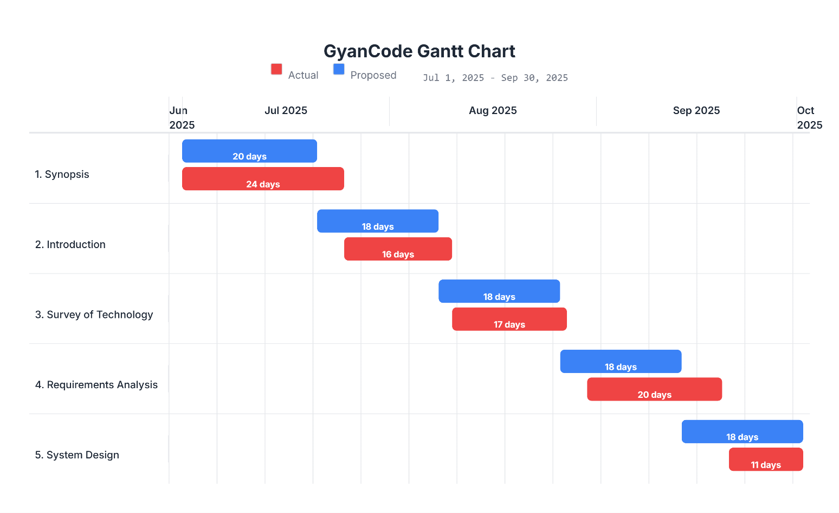
  - Software & Hardware Requirements

    - Software Requirements

The following software components are required for the development and deployment of the GyanCode Platform.
      - Operating System: Windows 10/11, macOS, or a Linux distribution (e.g., Ubuntu) for the development machine. The deployment server will run on a Linux-based environment managed by Firebase.
      - Web Browser: A modern web browser such as Google Chrome, Mozilla Firefox, or Microsoft Edge for accessing the application.
      - Code Editor/IDE: Visual Studio Code (recommended) for its excellent support for JavaScript, React, and Node.js, along with its integrated terminal and extension marketplace.
      - Runtime Environment: Node.js (version 16.x or later) to run the backend server and manage JavaScript packages.
      - Package Manager: npm (Node Package Manager), which is bundled with Node.js, for managing project dependencies.
      - Version Control: Git for source code management and tracking changes, along with a GitHub account for repository hosting.
      - Database: A Google Firebase account to access Firestore (NoSQL database) and Firebase Authentication services.

Compilers/Interpreters:
        - GCC (GNU Compiler Collection) for compiling C and C++ code on the backend server.
        - Python (version 3.x) interpreter for executing Python scripts.
        - JDK (Java Development Kit) for compiling and running Java code.
      - API Testing Tool: Postman or a similar tool for testing the backend API endpoints during development.

Hardware Requirements

The hardware requirements are divided into development machine specifications and server-side requirements for hosting.

For Development:

      - Processor: Intel Core i3 or equivalent AMD processor (Intel Core i5 or higher recommended).
      - RAM: Minimum of 8 GB RAM (16 GB recommended for smoother performance, especially when running multiple development tools).
      - Storage: At least 20 GB of free disk space for the operating system, development tools, project files, and dependencies. A Solid State Drive (SSD) is highly recommended for faster file access and build times.
      - Internet Connection: A stable broadband internet connection for accessing cloud services (Firebase, Google Gemini API) and managing packages.

For End-Users (Client-Side):

      - Any standard desktop, laptop, or mobile device capable of running a modern web browser.
      - A reliable internet connection.

For Deployment (Server-Side)::

      - The application will be deployed on Google's Firebase platform. Therefore, there are no specific hardware procurement requirements, as Firebase provides a serverless architecture that automatically manages and scales the underlying hardware resources based on traffic and load.

Feasibility Study

A feasibility study is conducted to evaluate the viability of the proposed project. It assesses whether the project is technically possible, economically justifiable, and operationally practical. This analysis helps in making an informed decision before committing significant resources to the project.

Technical Feasibility

Technical feasibility assesses the technical resources and expertise available to complete the project successfully. The GyanCode Platform is designed using a modern but well-established technology stack. The core technologies—React, Node.js, and Firebase—are widely used in the industry, have extensive documentation, and are supported by large, active communities. This abundance of resources significantly mitigates the technical risks associated with development.
The required software, such as VS Code, Node.js, and Git, is open-source and readily available. The hardware requirements for development are modest and can be met by any standard modern laptop or desktop computer. The cloud-based nature of Firebase eliminates the need for managing physical server infrastructure, which simplifies deployment and scaling. The most complex technical challenge is the secure execution of untrusted code. This will be addressed by using Node.js's child_process module to run code in isolated, sandboxed environments with strict resource limits (e.g., execution time, memory). This is a proven technique for building such systems.
The integration with the Google Gemini API is straightforward via a standard REST API call. The technical skills required for this project, including proficiency in JavaScript, React, and Node.js, are consistent with the curriculum of a B.Sc. (IT) program. Given these factors, the project is considered technically feasible.

Economic Feasibility

Economic feasibility evaluates the cost-effectiveness of the project. The development of the GyanCode Platform is highly cost-effective. The primary cost is the time and effort of the student developer. There are minimal direct financial costs, as the entire development stack is based on free and open-source software.
      - Development Costs: There are no software licensing fees. Visual Studio Code, Node.js, Git, and the required compilers are all free to use.
      - Hosting and Service Costs: Google Firebase offers a generous free tier ("Spark Plan") that is more than sufficient for the development, testing, and initial deployment phases of this project. This plan includes Firestore database usage, authentication, and hosting at no cost, up to certain limits.
      - API Costs: The Google Gemini API also provides a free tier that allows for a substantial number of API calls per minute, which will be adequate for development and small-scale use.
      - Hardware Costs: No new hardware needs to be purchased, as the project can be developed on existing personal computers.
The long-term benefits of the platform, such as saving educators' time, improving student engagement, and enhancing learning outcomes, provide significant intangible value that far outweighs the negligible development costs. Therefore, the project is economically feasible.

Operational Feasibility

Operational feasibility assesses how well the proposed system will solve the problems and be accepted by its intended users (students and educators). The GyanCode Platform is designed to be highly operational and user-friendly. It directly addresses the pain points of the current manual system. For educators, it automates the tedious task of grading, freeing up their time to focus on teaching. The intuitive dashboard for creating assignments and monitoring progress will be a significant improvement over managing files in emails and folders.

For students, the platform offers a much-improved user experience. The elimination of local environment setup removes a major technical hurdle. The immediate feedback loop provided by real-time execution and AI-powered hints will make the learning process more interactive and effective. The user interface will be designed to be clean and modern, inspired by popular tools like VS Code, which students are likely familiar with. Since the platform is web-based, it is accessible from any device with a browser, making it highly convenient. The proposed system aligns well with the existing workflow of assigning and submitting practical work, but digitizes and automates it, ensuring a smooth transition and high adoption rate among both students and faculty. The project is therefore operationally feasible.

Fact Finding Techniques

To ensure the GyanCode Platform effectively meets the needs of its users, a thorough analysis was conducted using various fact-finding techniques. These methods were employed to gather information about the existing system's shortcomings, user expectations, and the specific requirements for the new platform. The primary techniques used were Observation, Record Review, Questionnaires, and Interviews.

Observation

Observation involves systematically watching and recording the behavior of people, objects, and events as they occur within their natural setting. For this project, the process of how programming assignments are currently handled in a typical B.Sc. (IT) practical lab session was observed. This provided direct, firsthand insight into the workflow, challenges, and inefficiencies of the existing manual system.
The observation was conducted during a scheduled practical lab for a programming course. The key activities observed included the educator distributing the assignment problem statement, students setting up their local IDEs (like Code::Blocks for C++ or IDLE for Python), writing their code, and the process of submission. It was noted that a significant amount of time at the beginning of the session was spent by students dealing with configuration issues, such as incorrect compiler paths or missing libraries, which required individual attention from the educator and delayed the start of the actual coding task.
During the coding phase, students frequently raised their hands to ask the educator to check their code or to clarify doubts about why their program was not working as expected. The educator had to move from one student to another, providing one-on-one debugging help, which was inefficient in a large class. The submission process was also observed to be chaotic. Some students copied their code files to a pen drive, while others emailed them to the educator. This created a logistical challenge for the educator in collecting and organizing all the submissions.
The post-lab observation focused on the educator's assessment process. It involved watching the educator download each student's file, open it in the appropriate IDE, compile it, run it with sample inputs, and then manually compare the output to the correct answer. This entire process was observed to be extremely time-consuming and repetitive. The insights gained from this observation directly informed the core requirements of the GyanCode Platform, particularly the need for a standardized online environment to eliminate setup issues and an automated system for submission and grading to save educator time and provide instant feedback to students.

Record Review

Record review, also known as document analysis, is the process of examining existing documents and records to extract information relevant to the project. This technique provides quantitative and historical data that can help in understanding the scale of the problem and in defining the system's requirements. For this project, several types of records were reviewed.
First, past programming assignment question papers from previous semesters were analyzed. This review helped in understanding the typical structure, complexity, and format of assignments given to students at different academic levels (First Year, Second Year, Third Year). It was found that assignments range from simple syntax-based exercises for beginners to more complex problems involving data structures and algorithms for advanced students. This analysis informed the design of the assignment creation module, specifically the need for categorizing assignments by proficiency level.
Second, a sample of graded student submission records (in the form of code files with feedback comments) was reviewed. This provided insight into the common types of errors students make, such as logical errors, syntax errors, and misunderstanding of the problem statement. It also revealed the nature of the feedback provided by educators. The feedback was often brief and sometimes inconsistent across different submissions. This highlighted the need for the AI-powered hint system to provide standardized, constructive, and educational feedback that guides students to correct their own mistakes.
Third, course syllabi and curriculum documents for the B.Sc. (IT) program were reviewed. This was crucial for identifying the range of programming languages that the platform must support. The review confirmed the importance of including C, C++, Python, Java, and web technologies (HTML/CSS/JS) to align with the curriculum. It also helped in structuring the platform's content organization around academic years and specific courses.

Finally, feedback forms and course-end surveys from previous years were examined. These records contained students' and educators' written opinions about the practical courses. Common themes that emerged were complaints about the delay in getting grades, the difficulty of setting
up software, and the heavy workload for educators. This data provided strong validation for the problem statement and reinforced the purpose and objectives of the GyanCode Platform.

Questionnaires

Questionnaires were used to gather data from a larger group of stakeholders—specifically, students and educators—in a structured manner. This technique is efficient for collecting opinions and identifying common trends and preferences. Separate questionnaires were designed for students and educators to address their unique perspectives. Below is a sample questionnaire designed for students, along with representative answers that reflect the general sentiment gathered.

Student Questionnaire on Programming Assignment Experience

This questionnaire aims to understand your experience with the current system for programming assignments. Your feedback will be used to design a new, improved platform. Please select the most appropriate answer.

How often do you face issues with setting up the required software (IDE, compilers) for your programming assignments on your personal computer?
  - User's Answer: Very Often. It's frustrating when the code works on a friend's PC but not mine because of a setup issue.

On a scale of 1 to 5 (where 1 is very slow and 5 is very fast), how would you rate the speed at which you receive feedback on your submitted assignments?
  - User's Answer: 2 (Slow). We usually get feedback after a week or more, by which time we have already moved on to the next topic.

How helpful do you find the feedback you currently receive on your programming assignments?
  - User's Answer: Moderately helpful. Sometimes it's just the marks, and we don't know where we went wrong.

Would you be more motivated to practice coding if you could get instant results (pass/fail) on your attempts?
  - User's Answer: Absolutely, yes. Instant feedback would help me learn much faster and keep me engaged.

Which of the following programming languages do you use most frequently for your assignments? (Select all that apply)
  - User's Answer: C++, Python, Java.

How important is it for you to be able to write and run your code in a web browser without any local installation?
  - User's Answer: Very important. It would make things much simpler and allow me to work from any computer.

If a system gave you a hint when your code was wrong (without giving the answer), would you find that useful?
  - User's Answer: Yes, that would be incredibly useful. It's better than being stuck with no idea how to proceed.

Do you think a points system or leaderboard for completing assignments would make learning more fun?
  - User's Answer: Yes, it would add a competitive and fun element to it.

Have you ever lost your assignment code file or had trouble submitting it via email?

  - User's Answer: Yes, I have accidentally submitted the wrong version of a file before.

What is the single biggest improvement you would like to see in the way programming assignments are managed?
  - User's Answer: A single online platform where we can see the question, write the code, run it, and submit it, all in one place, with immediate feedback.

Interview

Interviews are a formal, one-on-one communication method used to gather detailed and in-depth information. For this project, interviews were conducted with key stakeholders: a senior faculty member who teaches multiple programming courses and a group of third-year students who have experienced the traditional system for several years. The interviews were semi-structured, allowing for open-ended questions and follow-up discussions to explore topics in greater detail.
The interview with the faculty member focused on the administrative and pedagogical challenges of the current system. The professor highlighted that the manual assessment process consumes a significant portion of their time, which could be better spent on preparing lectures or providing more personalized help to struggling students. They confirmed that ensuring academic integrity is a major concern, as it is difficult to detect plagiarism when students submit code files via email. The professor expressed strong interest in a platform that could automate grading, manage submissions centrally, and provide a clear overview of the entire class's performance. They also provided valuable input on the desired features for the assignment creation module, emphasizing the need for flexibility in defining test cases (inputs and outputs) to cover various edge cases.
The interview with the group of students provided qualitative insights into their learning experience. Students expressed frustration with the "black box" nature of the current submission process, where they submit their code and wait for days to know the outcome. They felt that this delay broke their learning momentum. They elaborated on the benefits of an instant feedback system, stating that it would allow them to experiment with different solutions and learn by doing, which is crucial for programming. The students were enthusiastic about the idea of an AI-powered hint system, comparing it to having a tutor available on demand. They also suggested that the platform should have a simple and clean user interface, similar to modern online editors they use for personal projects, and that it should track their progress over time, perhaps even leading to a certificate that could be valuable for their resumes.

Overall, the information gathered from these interviews was invaluable. It confirmed the core assumptions of the project, provided detailed user requirements, and helped in prioritizing features for the GyanCode Platform. The strong positive reception of the proposed system's concept from both educators and students underscored its potential impact and operational feasibility.

Chapter 4: System Design

Design Diagrams

System design is the process of defining the architecture, components, modules, interfaces, and data for a system to satisfy specified requirements. This section presents a series of UML (Unified Modeling Language) and ER (Entity-Relationship) diagrams to visually represent the design of the GyanCode Platform from different perspectives.
    - E-R Diagram

Diagrammatic Preview:
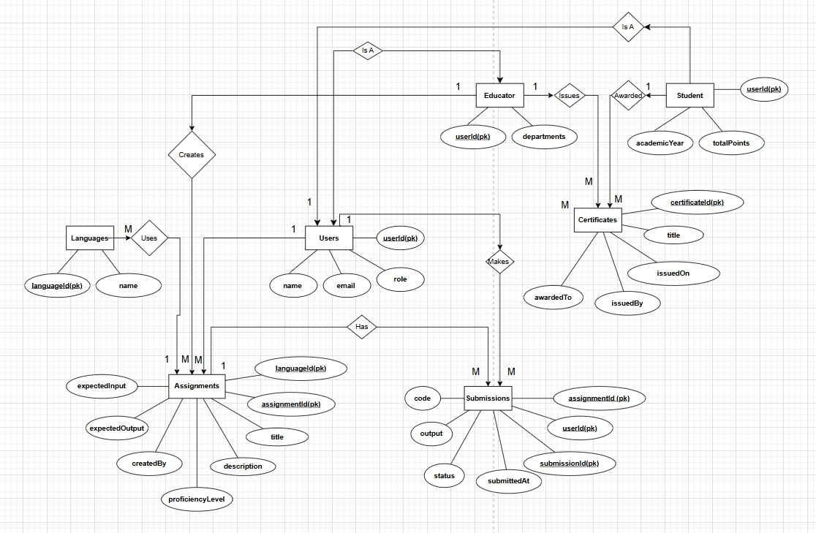

Explanation:

This Entity-Relationship (ER) diagram illustrates the high-level data model for the GyanCode Platform. It identifies the main entities within the system and the relationships between them. The core entities are USERS, ASSIGNMENTS, and SUBMISSIONS. The USERS entity is specialized into STUDENT and EDUCATOR, showing an "Is a" relationship. An EDUCATOR creates multiple ASSIGNMENTS, and a STUDENT makes multiple SUBMISSIONS. Each ASSIGNMENT corresponds to one LANGUAGE and can have many SUBMISSIONS, while each SUBMISSION belongs to only one ASSIGNMENT and is made by one STUDENT.

Symbol Name | Symbol | Symbol Explanation
Entity | ▭ (Rectangle) | Represents a real-world object or concept, such as Customer, Order, or Product.
Attribute | ◯ (Ellipse) | Describes details or properties of an entity, like name, price, or toppings.
Relationship | ◆ (Diamond) | Shows how two or more entities are connected or interact with each other, like “places” or “creates”.
Line | — (Line) | Connects entities with relationships and attributes, showing associations between them.
Multivalued Attribute | ◯◯ (Double Ellipse) | Represents attributes that can have multiple values, like a list of toppings.
Derived Attribute | ◯ (Dashed Ellipse) | Indicates attributes calculated from other data, like total price derived from selected items.

    - Class Diagram

Diagrammatic Preview:

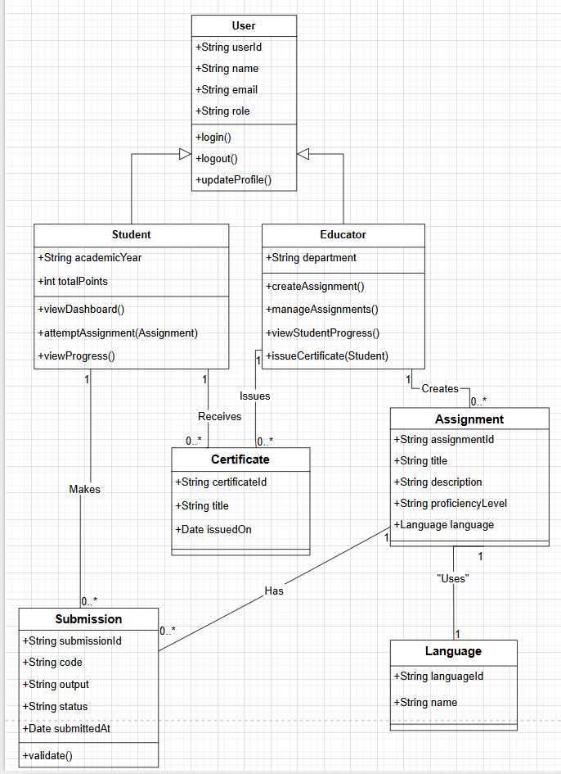

Explanation:

The Class Diagram provides an object-oriented view of the system's structure. It shows the main classes, their attributes, methods, and the relationships between them. The central class is User, from which Student and Educator inherit, demonstrating a generalization-specialization hierarchy. An Educator is associated with creating Assignment objects, while a Student makes Submission objects. The diagram clearly defines the static structure and the blueprint for how objects will interact within the GyanCode Platform, including their responsibilities and connections.

Symbol Name | Symbol | Symbol Explanation
Public | + | Accessible from anywhere.
Private | - | Accessible only within the class.
Protected | # | Accessible within the class and its subclasses.
Package (Default) | ~ | Accessible only within the same package/module.
Association | ClassA───ClassB | Structural link between two classes.
Multiplicity | 1..*, 0..1, * | Specifies how many instances are linked.
Aggregation | ClassA ◇─── ClassB | Weak "has-a" relationship; ClassB can exist independently.
Composition | ClassA ◆─── ClassB | Strong "has-a" relationship; ClassB cannot exist without ClassA.
Inheritance / Generalization | ClassA ─▷ ClassB | ClassA inherits from ClassB.
Realization | Class ─▷ (dashed) Interface | A class implements an interface.
Dependency | ClassA ──> ClassB (dashed) | Temporary/weak dependency (uses).

Use Case Diagram Diagrammatic Preview:
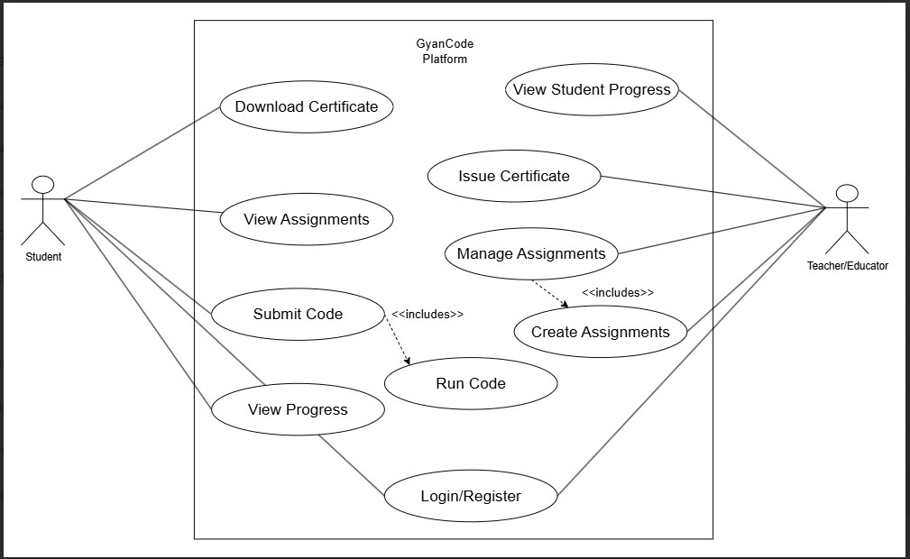

Explanation:

This Use Case Diagram captures the functional requirements of the system from the user's perspective. It identifies the primary actors, Student and Educator, and the key interactions (use cases) they can perform. A Student can perform actions like viewing assignments, running code, submitting solutions, and tracking their progress. An Educator can manage the learning content by creating assignments, monitoring student progress, and issuing certificates. The diagram also shows that both actors share a common use case, Login/Register, highlighting the shared authentication functionality.

Symbol Name | Symbol (Textual Representation) | Symbol Explanation
Actor | 🧍(Stick figure) or <<actor>> ActorName | Represents a user or external entity that interacts with the system. Actors can be human users, devices, or external systems.
Use Case | (Use Case Name) (Oval shape) | Represents a functional requirement of the system – what the actor can do with the system.
Association | Actor ─── (Use Case) | A solid line connecting an actor to a use case, representing interaction.

    - Sequence Diagram

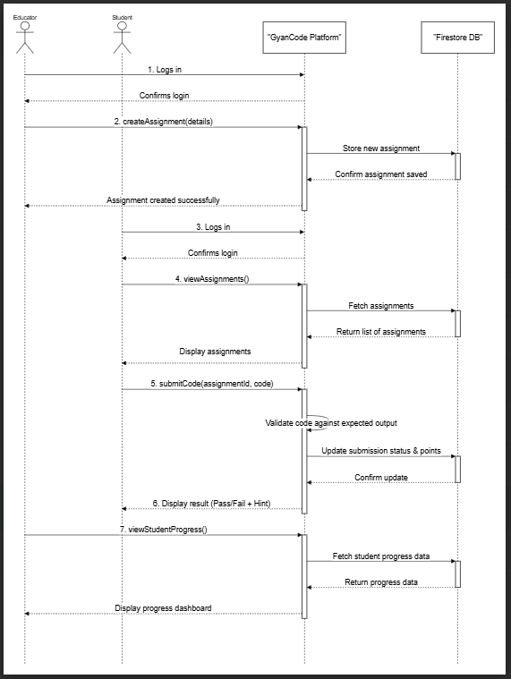
Scenario: Student Submits Code for Validation Diagrammatic Preview:

Explanation:

This Sequence Diagram illustrates the interactions between different system components over time for a specific scenario: a student submitting their code. The diagram shows the flow of messages starting from the student’s action on the Frontend UI. The request is sent to the Backend Server, which then orchestrates the process by fetching data from Firestore DB, executing the code via the Code Executor, and conditionally calling the Gemini API if the output is incorrect. This visual representation clarifies the step-by-step logic and dependencies involved in the automated validation process.

Symbol Name | Symbol | Symbol Explanation
Actor | 🧍 (Stick Figure) | Represents a user or external system interacting with the system. In sequence diagrams, actors initiate interactions.
Object / Lifeline | ObjectName:ClassName with a vertical dashed line | Denotes a participant in the interaction. The vertical dashed line (lifeline) represents its existence over time.
Activation Box | Narrow rectangle over lifeline | Shows the period when an object is active/performing a process or method.
Message (Synchronous) | Solid horizontal arrow with filled head | Represents a call/request from one object to another, requiring a response (blocking call).
Message (Asynchronous) | Solid horizontal arrow with open head | Represents a non-blocking call/request where the sender continues without waiting for a reply.
Return Message | Dashed horizontal arrow | Represents the response or return value from a synchronous message.
Self-Message | Arrow looping back to same lifeline | Shows an object sending a message to itself (recursive call or internal process).
Create Message | Arrow pointing to a lifeline’s head | Represents the creation/instantiation of an object during runtime.
Destroy Message | Cross (X) at end of lifeline | Indicates termination or deletion of an object.
Interaction Fragment (alt/opt/loop) | Box with label (e.g., alt, opt, loop) | Used for conditional/iterative behavior. alt = alternatives, opt = optional, loop = repetition.

    - Activity Diagram

Workflow: Assignment Assessment Process
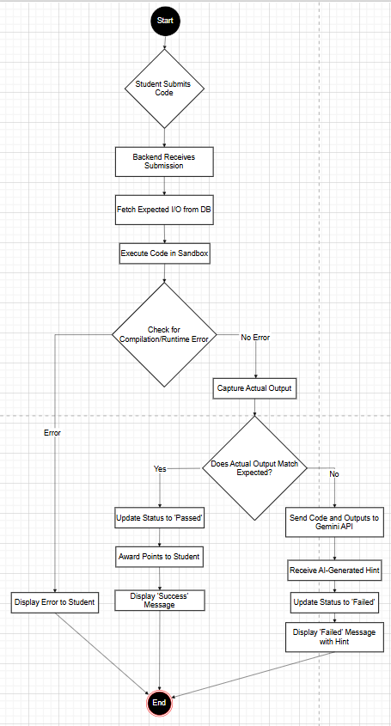

Diagrammatic Preview:

Explanation:

The Activity Diagram models the dynamic workflow of the assignment assessment process from start to finish. It begins when a student submits their code and flows through various actions and decisions within the system. The diagram clearly shows the conditional paths: if the code has an error, if the output is correct, or if the output is incorrect. This visualization helps in understanding the business logic and the sequence of operations involved in automated grading, including the integration of the AI hint generation step. It provides a clear, high-level overview of the entire process flow.

Symbol Name | Symbol | Symbol Explanation
Initial Node | ● (Filled Black Circle) | Denotes the starting point of the activity diagram where the workflow begins.
Activity/Action | ▭ (Rounded Rectangle) | Represents a task, step, or activity in the workflow.
Decision Node | ◆ (Diamond) | Indicates a decision point where the flow branches based on conditions (Yes/No, True/False).
Merge Node | ◆ (Diamond) | Combines multiple alternate flows back into a single flow.
Fork Node | ─●─ (Thick Horizontal/Vertical Bar with one incoming and many outgoing flows) | Splits a single flow into multiple parallel flows.
Join Node | ─●─ (Thick Horizontal/Vertical Bar with many incoming and one outgoing flow) | Synchronizes multiple parallel flows into one.
Final Node | ◎ (Circle with Border and Filled Inner Circle) | Marks the end of the process or activity flow.
Transition/Control Flow | → (Arrow) | Shows the direction of workflow from one activity or decision to another.
Object Node | [Object] (Rectangle) | Represents the object/data that is created, updated, or used in the activity.
Swimlane/Partition | Vertical/Horizontal Dividing Lanes | Used to group activities by actor, role, or system component to show responsibility.

Module Design

The GyanCode Platform is designed using a modular approach to ensure the system is organized, maintainable, and scalable. Each module represents a distinct functional area of the application with a specific set of responsibilities. This separation of concerns simplifies development, testing, and future updates.

Module Names with Description

- User Management & Authentication Module:
  - Description: This module is responsible for handling all aspects of user accounts. It manages user registration, login, logout, and session persistence. It also enforces role-based access control, distinguishing between Student and Educator users and granting them appropriate permissions throughout the application.

Assignment Management Module (Educator):
  - Description: This is an educator-facing module that provides the complete functionality for managing academic content. It allows educators to perform CRUD (Create, Read, Update, Delete) operations on programming assignments. This includes defining problem statements, setting proficiency levels, assigning points, and specifying the test cases (expected inputs and outputs).

Student Workspace Module:
  - Description: This module constitutes the primary learning environment for the student. It includes the assignment browsing and filtering interface, the integrated code editor, and the real-time code execution functionality. It provides the user interface for students to write, run, and test their code against custom inputs before final submission.

Automated Assessment Module:
  - Description: This is a backend module that forms the core of the automated grading system. It receives a student's code submission, retrieves the corresponding assignment's test cases, and invokes the code execution engine. It is responsible for comparing the actual output with the expected output and determining the pass/fail status of the submission.

AI Feedback & Hint Generation Module:
  - Description: This module integrates with the Google Gemini API. When the Automated Assessment Module detects an incorrect submission, this module is triggered. It constructs a prompt containing the student's code and the I/O details and sends it to the AI model to generate a constructive, educational hint for the student.

Progress Tracking & Reporting Module:
  - Description: This module is responsible for recording, processing, and displaying user progress data. For students, it powers their personal dashboard with statistics and visualizations of their performance. For educators, it provides a comprehensive class-wide view of student progress, enabling them to monitor performance in real time.

Certification Module:
  - Description: This module handles the creation and issuance of digital certificates. It contains functionality for educators to trigger the generation of a certificate for a student. On the backend, it generates a personalized PDF document from a template and makes it available for the student to download.

Module Functionality

- User Management & Authentication Module:
  - Provides secure user registration with email and password.
  - Handles user login and securely manages user sessions.
  - Implements middleware to protect routes based on user roles (Student/Educator).
  - Allows users to update their profile information.

Assignment Management Module (Educator):
  - Presents a form for creating a new assignment with fields for title, description, language, level, points, and I/O test cases.
  - Displays a list of all created assignments with options to edit or delete them.
  - Validates all inputs to ensure data integrity before saving an assignment to the database.

Student Workspace Module:
  - Fetches and displays a list of available assignments from the database.
  - Provides filtering options for assignments (by language, level, status).
  - Integrates a code editor component (e.g., Monaco Editor) with syntax highlighting.
  - Provides an "Run" button that sends the code and custom input to the backend for execution and displays the output.
  - Provides a "Submit" button to initiate the formal assessment process.

Automated Assessment Module:
  - Receives API requests containing the student's code and assignment ID.
  - Spawns a secure, isolated child process to compile and execute the code.
  - Captures the standard output (stdout) and standard error (stderr) from the execution.
  - Performs a strict comparison between the captured output and the stored expected output.
  - Returns a JSON response indicating the result (e.g., pass, fail, compile_error).

AI Feedback & Hint Generation Module:
  - When a submission fails, it formats a prompt for the Gemini API.
  - Sends a POST request to the Google Gemini API endpoint.
  - Parses the API response to extract the generated hint text.

  - Logs the interaction for monitoring and improvement purposes.
  - Includes the hint in the response sent back to the student's frontend.

Progress Tracking & Reporting Module:
  - Updates the Firestore database in real time when an assignment is passed.
  - Aggregates data to calculate total points for each student.
  - Provides API endpoints to fetch progress data for student and educator dashboards.
  - Uses Chart.js on the frontend to render this data into doughnut charts or bar graphs.

Certification Module:
  - Provides a button on the educator's dashboard to "Issue Certificate" for a specific student.
  - Uses a backend library (e.g., pdf-lib or Puppeteer) to generate a PDF from an HTML template, populating it with the student's name, course, and date.
  - Saves the generated PDF to Firebase Storage.
  - Creates a record in Firestore linking the certificate to the student's profile.

Schema Design

    - Database Design

The database for the GyanCode Platform is designed using Firestore, a NoSQL,
document-oriented database. This model provides flexibility and scalability, which is well-suited for the application's data structure. The schema is organized into top-level collections, where each collection contains documents that store the data.
Users Collection
This collection stores profile information for every user, both students and educators.

Field Name | Data Type | Description
userId (PK) | String | Unique ID from Firebase Auth. Serves as the Document ID.
name | String | Full name of the user.
email | String | The user's email address (used for login).
role | String | The user's role, either "student" or "educator".
academicYear | String | (For students only) e.g., "TY", "SY".
totalPoints | Number | (For students only) Total points accumulated.
department | String | (For educators only) e.g., "Information Technology".

Assignments Collection
This collection contains all the programming assignments created by educators.

Field Name | Data Type | Description
assignmentId (PK) | String | Auto-generated unique Document ID.
title | String | Title of the assignment.
description | String | The detailed problem statement.
language | String | The programming language (e.g., "Python", "C++").
proficiencyLevel | String | "Beginner", "Intermediate", or "Professional".
points | Number | Points awarded for successful completion.
expectedInput | String | The standard input to be tested against.
expectedOutput | String | The required output for the given input.
createdBy | String | The userId of the educator who created it.
createdAt | Timestamp | The date and time of creation.

Submissions Collection
This collection stores a record of every attempt a student makes on an assignment.

Field Name | Data Type | Description
submissionId (PK) | String | Auto-generated unique Document ID.
assignmentId | String | Reference to a document in the assignments collection.
userId | String | Reference to a student document in the users collection.
code | String | The source code submitted by the student.
status | String | Result of the submission ("passed", "failed", "error").
submittedAt | Timestamp | The timestamp of the submission.
language | String | The language of the submission.
lastHint | String | (Optional) The last AI-generated hint for a failed attempt.

Certificates Collection
This collection stores records of all certificates issued to students.

Field Name | Data Type | Description
certificateId (PK) | String | Auto-generated unique Document ID.
awardedTo | String | The userId of the student receiving the certificate.
title | String | The title of the achievement (e.g., "Python Beginner Proficiency").
issuedBy | String | The userId of the educator who issued it.
issuedOn | Date | The date the certificate was issued.
storageUrl | String | The URL to the PDF file in Firebase Storage.

Data Integrity & Constraints

Ensuring data integrity is crucial for the reliability and accuracy of the GyanCode Platform. This involves maintaining the consistency, accuracy, and context of the data stored in the Firestore database. This is achieved through a combination of application-level logic and Firestore's built-in security rules.

Data Integrity (like data consistency, accuracy, timeliness etc.)

      - Data Consistency: Consistency is maintained by ensuring that related data across different collections are in sync. For example, when a student successfully completes an assignment, a transaction is used to perform two atomic operations: a new document is added to the submissions collection with a "passed" status, and the totalPoints field in the student's document within the users collection is updated. Using transactions ensures that both operations succeed or neither does, preventing a state where a submission is marked as passed but points are not awarded.
      - Data Accuracy: Accuracy is enforced through validation at both the client-side and the server-side. Before an educator creates an assignment, the frontend form validates that all required fields (like title, description, expectedOutput) are filled and are in the correct format. The backend API performs the same validation again before writing to the database. This prevents incomplete or malformed data from being saved. For student submissions, the status is determined solely by the backend's secure assessment module, ensuring the accuracy of the pass/fail result.
      - Data Timeliness: Timeliness is achieved by using server-generated timestamps for critical events. When a submission is made or a certificate is issued, the submittedAt or issuedOn fields are populated with a server timestamp (FieldValue.serverTimestamp()). This ensures that all time-based data is accurate and not dependent on the client's clock, which could be incorrect. Firestore's real-time capabilities also ensure that any changes to the data are immediately pushed to all connected clients, making dashboards and progress views timely and up-to-date.

Data Constraints (primary key, referential, not null, value constraints etc.)

While NoSQL databases like Firestore do not enforce schema and constraints in the same way as relational databases, these constraints are implemented through application logic and Firestore Security Rules.
      - Primary Key: In Firestore, the Document ID serves as the unique primary key for each document within a collection. For the users collection, the userId from Firebase Authentication is explicitly used as the Document ID to ensure a unique and easily referenceable key for each user. For other collections like assignments and submissions, Firestore's auto-generated unique IDs are used.
      - Referential Integrity: Although Firestore does not have foreign key constraints, referential integrity is maintained at the application level. For instance, a submission document contains a userId and an assignmentId. The application logic ensures that these IDs correspond to valid documents in the users and assignments collections. Before displaying a submission, the application fetches the related user and assignment data. Firestore Security Rules can also be written to ensure that a submission document can only be created if the userId matches the authenticated user and a corresponding assignment document exists.
      - Not Null Constraints: These are enforced through validation. For example, a security rule can be written to prevent the creation of an assignment document if the title or description fields are null or empty strings. request.resource.data.title != null && request.resource.data.title != ""
      - Value Constraints: Constraints on the values of a field are also managed via security rules and application logic. For example, the role field in a user document can be restricted to only accept the values "student" or "educator". Similarly, the proficiencyLevel in an assignment can be constrained to "Beginner", "Intermediate", or "Professional". A rule would look like: request.resource.data.role in ['student', 'educator']. This prevents invalid data from being written to the database.

User Interface Design

The user interface (UI) and user experience (UX) are critical to the success of the GyanCode Platform. The design aims to be clean, intuitive, and modern, drawing inspiration from familiar development tools like VS Code and Replit to create an environment where users feel comfortable and can focus on their tasks. The goal is to minimize the learning curve and maximize efficiency for both students and educators.
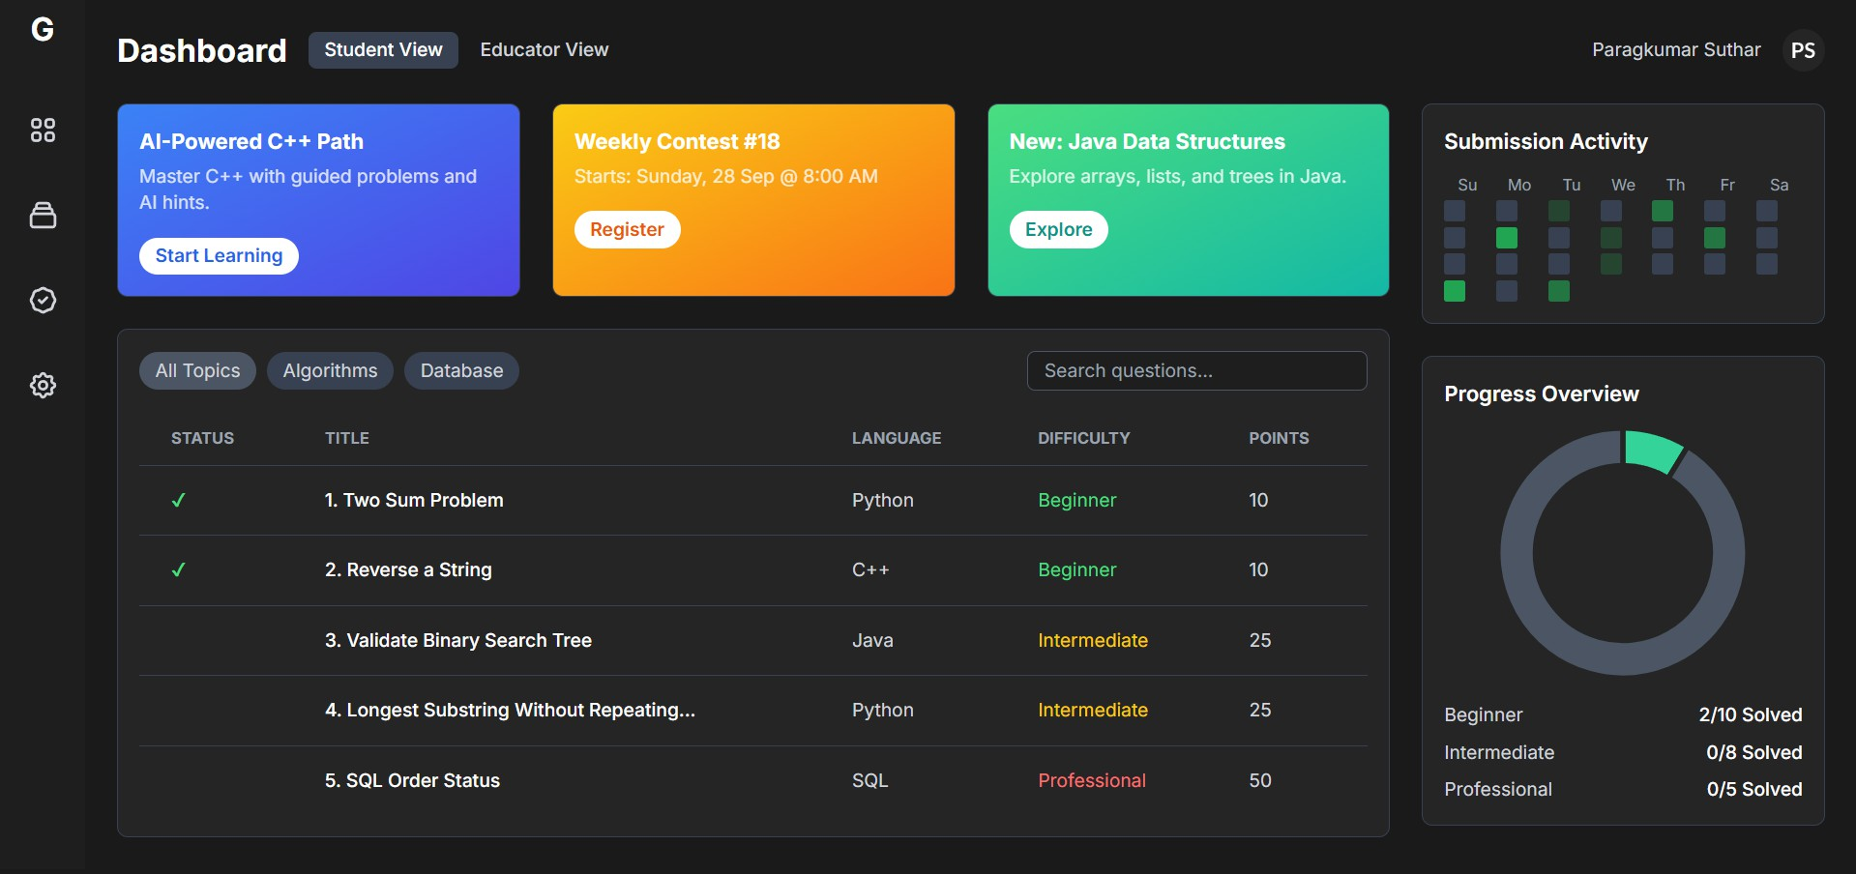

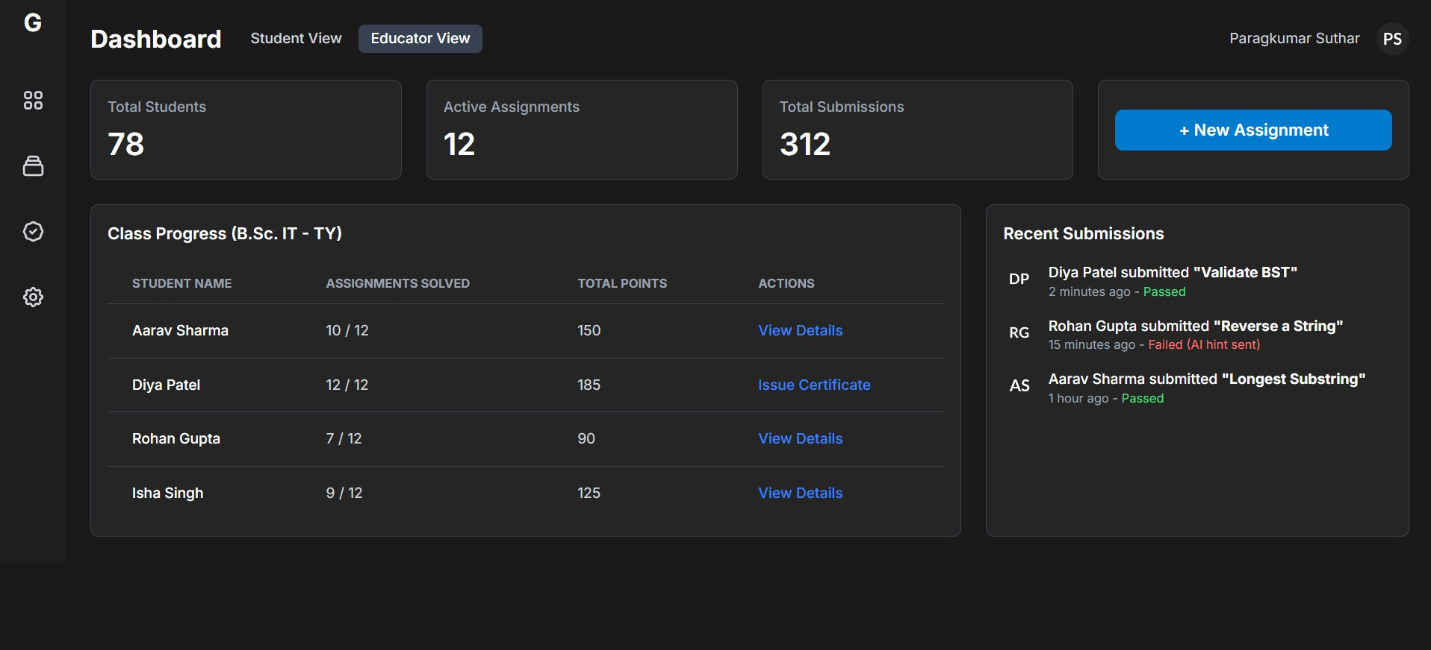

Design Consideration (like color scheme, typography, icons & graphics, responsive design etc.)
      - Color Scheme: The primary color scheme will utilize a professional and modern palette. A dark theme will be the default for the code editor and main workspace to reduce eye strain during long coding sessions, a common practice in developer tools. The palette will consist of a dark charcoal background (#1e1e1e), with syntax highlighting in vibrant but accessible colors (e.g., blues for keywords, greens for strings, oranges for numbers). UI elements outside the editor, such as sidebars and dashboards, will use a lighter dark grey (#252526) with a primary accent color (e.g., a bright blue like #007acc) for buttons, links, and active states to guide the user's attention.
      - Typography: The chosen font will be a clean, sans-serif typeface like 'Inter' or 'Roboto' for all interface text to ensure high readability. For the code editor itself, a monospace font such as 'Fira Code' or 'Source Code Pro' will be used, as these fonts are designed for programming, with clear distinctions between similar characters (e.g., '0' and 'O', '1' and 'l'). Font sizes will be legible, with a clear hierarchy established through different weights (regular, medium, bold) and sizes for headings, body text, and labels.
      - Icons & Graphics: Icons will be used to supplement text labels, providing quick visual cues for common actions. A consistent and minimalist icon set (e.g., from Lucide React or Feather Icons) will be used for actions like 'run code', 'submit', 'edit', 'delete', and 'download'. Graphics will be primarily used in the form of charts and graphs (via Chart.js) on the dashboard pages to present progress data in an easily digestible visual format.

      - Responsive Design: A mobile-first, responsive design is a key consideration. Using Tailwind CSS, the layout will adapt fluidly to different screen sizes. On desktops, a multi-column layout with a sidebar, main content area, and an output panel will be used. On smaller screens (tablets and mobiles), the layout will stack vertically, and the sidebar may become a collapsible drawer to maximize the usable screen real estate for the code editor and content. This ensures the platform is accessible and usable from any device.

UI/UX Design (like Quick access button, Gesture support, Feedback mechanism etc.)

      - Quick Access and Navigation: The interface will feature a persistent sidebar for primary navigation, allowing users to quickly switch between their dashboard, assignments list, and certificates page without losing context. Both students and educators will have a personalized dashboard that serves as their landing page, presenting the most relevant information and actions upfront, such as "Continue Last Assignment" for students or "View Recent Submissions" for educators.
      - Feedback Mechanism: The system is designed around providing clear and immediate feedback. When a user runs code, the output or error appears instantly in a dedicated console panel. After submission, the result ("Passed" or "Failed") is displayed prominently using clear visual indicators (e.g., a green checkmark for success, a red cross for failure). In case of failure, the AI-generated hint is displayed directly below the result, providing actionable guidance. Loading states (e.g., spinners on buttons) will be used during asynchronous operations like code execution to inform the user that the system is processing their request.
      - Clarity and Simplicity: The UX philosophy is to keep the interface uncluttered and focused on the task at hand. The assignment view will present the problem statement clearly on one side and the code editor on the other. There will be no unnecessary visual elements to distract the user. The process will be linear and intuitive: read the problem, write the code, run to test, and submit for grading. This simplicity is crucial for creating an effective learning environment.
      - Gesture Support: While the platform is primarily designed for keyboard and mouse interaction, the responsive design will ensure that all interactive elements, like buttons and navigation links, are large enough to be easily tappable on touch devices, providing a good user experience for tablet and mobile users.

Security Issues

Security is a paramount concern for any web-based application, especially one that executes user-submitted code and handles user data. The security strategy for the GyanCode Platform is multi-layered, addressing potential vulnerabilities at the data, application, and infrastructure levels.

Security Issues related to project

- Arbitrary Code Execution: The most significant security risk is the execution of untrusted code submitted by users. A malicious user could submit code designed to harm the server, such as deleting files, accessing sensitive information, starting an infinite loop to consume all CPU resources (Denial of Service), or attempting to access the network.
- Unauthorized Access: Without proper access control, a student might be able to access educator functionalities, such as creating assignments or viewing other students' submissions. Users could also potentially view or modify data that does not belong to them.
- Data Breaches: User data, including names, emails, and submission history, is sensitive information. If the database is not properly secured, it could be vulnerable to unauthorized access, leading to a data breach.
- Cross-Site Scripting (XSS): If user-generated content (like assignment descriptions or code submissions) is rendered on the page without proper sanitization, an attacker could inject malicious scripts that execute in the browsers of other users, potentially stealing session tokens or other sensitive information.
- Insecure API Endpoints: The backend APIs, if not properly secured, could be exploited. For example, an attacker could repeatedly call the code execution API to launch a Denial of Service (DoS) attack or attempt to manipulate API requests to gain unauthorized permissions.

Security Policy and Plan

- Sandboxed Code Execution: To mitigate the risk of arbitrary code execution, all user-submitted code will be executed in a secure, isolated sandbox. This will be achieved using containerization technologies (like Docker) or by running the code in a child process with restricted permissions using Node.js's child_process module. The execution environment will have:
  - No access to the server's file system outside of a temporary, designated directory.
  - No network access.
  - Strict resource limits (timeout for execution time, maximum memory allocation) to prevent DoS attacks.

Role-Based Access Control (RBAC):
  - Authentication: Firebase Authentication will be used for secure user authentication. It handles password hashing and session management securely.
  - Authorization: Firestore Security Rules will be implemented to enforce strict RBAC at the database level. These rules will ensure that users can only read or write data for which they have explicit permission. For example, a rule will state that a user can only update their own profile document (allow update: if request.auth.uid == userId;) and that only users with the "educator" role can write to the assignments collection.

Data Protection:
  - Encryption in Transit: All communication between the client browser and the server will be encrypted using SSL/TLS (HTTPS), which is provided by default with Firebase Hosting.
  - Encryption at Rest: All data stored in Firestore is automatically encrypted at rest by Google Cloud.

Preventing XSS:
  - The React framework, by default, escapes content rendered in JSX, which provides a strong defense against XSS attacks.
  - All user-generated content, especially assignment descriptions created by educators, will be sanitized on the server before being stored and rendered to ensure no malicious scripts are embedded.

API Security:
  - All API endpoints will be protected by an authentication middleware that verifies the user's identity and role before processing any request.
  - Rate limiting will be implemented on resource-intensive endpoints (like code execution and AI hint generation) to prevent abuse and DoS attacks.
  - The application will validate and sanitize all incoming data from API requests to prevent injection attacks.

Chapter 5: Implementation and Testing
The implementation phase of GyanCode represents the translation of the system's architectural blueprints into a fully functional, cloud-deployed platform. Built upon a modern React + Vite frontend and a Node.js/Express backend, the system leverages Supabase (PostgreSQL) as its primary data layer, thereby removing the need for a self-managed database server. Google Gemini API and OpenRouter (DeepSeek R1 fallback) power all AI-driven features, including code execution simulation, AI hint generation, and the GyanBot tutor. Every component was developed following a modular, component-driven approach that ensures maintainability and future scalability.
The development cycle was structured into three sequential sprints. The first sprint concentrated on authentication, role-based access control, and the core assignment CRUD operations. The second sprint introduced the AI execution engine, the submission pipeline with automatic point rewards, and the educator dashboard analytics. The third and final sprint delivered the certification system, the leaderboard, student progress charts, and the system-wide report export. Throughout all sprints, version control was maintained through Git, and environment-specific configuration was kept separate via .env files, preventing sensitive keys from entering the public repository.
The testing strategy adopted for GyanCode was multi-layered, encompassing unit testing of isolated utility functions, integration testing of API endpoints against the live Supabase instance, and beta testing with actual students and educators. The system was deployed to production early (Vercel for the frontend and Render for the backend) so that real-world network conditions and authentication flows could be validated continuously rather than only at the end of the project. This continuous-deployment model dramatically accelerated the feedback loop and revealed edge cases — particularly around JWT expiry and AI API rate limits — that would have otherwise been difficult to reproduce in a purely local environment.
Row Level Security (RLS) policies enforced at the Supabase PostgreSQL layer ensure that students can only access their own data, educators can view all student submissions, and administrators retain unrestricted access across every table. The is_educator() and is_admin() SQL functions, defined with SECURITY DEFINER, are evaluated server-side for every database call, creating a tamper-proof access control layer independent of frontend logic. Middleware functions (authenticate and authorize) on the Express backend double-validate every incoming request before it reaches a route handler, providing defence-in-depth security.
The culmination of the implementation effort is a platform that is live, accessible through a public URL, and actively used by learners. The following sections detail the specific implementation strategies, code efficiency measures, testing methodologies, modifications made during development, and the formal test cases used to validate system correctness.
5.1 Implementation Approach
GyanCode was implemented using a full-stack JavaScript approach, allowing a single language — and often shared logic — to span both the frontend and backend. The frontend was scaffolded with Vite + React, providing near-instantaneous hot-module replacement during development and an optimised production bundle at deployment time. Routing was handled by React Router v6, and global state was managed by lightweight useState/useEffect hooks, avoiding the overhead of large state-management libraries for a project of this scope.
On the server side, Express.js was chosen for its minimal footprint and rich ecosystem. Each HTTP route is protected by the authenticate middleware, which extracts and validates the Supabase JWT from the Authorization header, and then optionally by authorize(['Admin']) for privileged operations such as managing platform settings or bulk-deleting users. All database mutations bypass the client-side Row Level Security and instead use the supabaseAdmin service-role client, which provides elevated privileges — an intentional design decision that keeps business logic in the server layer rather than exposing it to the browser.
The AI execution engine, located in backend/utils/ai.js, exposes three key functions: simulateExecutionAI for running code against a single input, verifySubmissionAI for batch-testing all test cases and performing semantic logic validation, and generateHint for generating personalised, contextual hints when a student's submission fails. The runAITask wrapper transparently switches between the Gemini API and DeepSeek R1 (via OpenRouter) based on quota availability, ensuring continuous uptime even when primary API limits are reached.

5.2 Coding Details and Efficiency
GyanCode's codebase follows the principle of separation of concerns: UI components in frontend/src/pages/, reusable presentation components in frontend/src/components/, utility helpers in frontend/src/utils/, and all business logic consolidated within backend/server.js and backend/utils/. This structuring minimises coupling and simplifies both testing and future maintenance.
Data fetching is performed through direct REST calls to the Express backend rather than through the Supabase JavaScript client on the frontend. This architectural choice means that all RLS-bypass operations are handled server-side, preventing accidental exposure of the service-role key in browser bundles. Educator and admin dashboards make use of parallel Promise.all patterns where appropriate — for example, simultaneously fetching students and submissions lists — reducing overall page load latency. Pagination and lazy loading are applied on the Assignments page to prevent performance degradation as the assignment library grows.
Chart.js is used for rendering submission trend graphs and success/failure pie charts on the Educator Dashboard and Student Progress pages. Chart instances are destroyed and re-initialised on component unmount to prevent memory leaks, a common pitfall with canvas-based charting libraries in React's Virtual DOM reconciliation model. The reportGenerator.js utility uses the SheetJS (xlsx) library to produce multi-sheet Excel exports of system statistics on demand, supporting the educator's reporting requirements without requiring any server-side file generation.
5.2.1 Code Efficiency
Efficiency in GyanCode is addressed at both the algorithmic and infrastructure level. On the backend, assignment lists are enriched with submission counts in a single post-fetch aggregation rather than issuing one database query per assignment, reducing the number of round-trips from O(n) to O(1) per list request. The leaderboard endpoint similarly computes period-filtered rankings in-memory after fetching a single, appropriately scoped result set from Supabase.
On the frontend, React's useMemo and useCallback hooks are applied to expensive filter/sort operations such as the student search bar on the Admin Panel, preventing redundant re-computations on every render cycle. Suspense-style skeleton loaders are shown while API calls resolve, maintaining perceived responsiveness. Code-splitting via Vite's dynamic import is used for large page components (e.g., AdminPanel and Certificates), reducing the initial bundle size and improving the First Contentful Paint metric.
5.3 Testing Approach
Testing for GyanCode was conducted across three distinct levels: unit testing of discrete utility functions, integration testing of REST API endpoints, and user-centric beta testing with real participants. This stratified approach ensured that defects were caught as close to their origin as possible, minimising the cost of remediation.
Before formal test execution, a test planning phase identified all critical paths — authentication, assignment submission, point increment, automatic certificate issuance, and AI hint generation — as the highest-priority areas for coverage. Edge cases such as expired deadlines, duplicate successful submissions, and AI API failures were explicitly documented and scripted as test scenarios to ensure that the system degraded gracefully in each case rather than throwing unhandled exceptions.
5.3.1 Unit Testing
Unit tests were written for the AI utility module (backend/test-ai.js) and the model availability checker (backend/test-models.js) to verify that prompt construction, response parsing, and fallback switching logic behaved correctly in isolation. Each function was exercised with both valid and invalid inputs — including intentionally malformed code and empty-string edge cases — to confirm robust error handling. The increment_points PostgreSQL function was validated via direct SQL assertions in the Supabase SQL Editor, confirming atomicity and correct accumulation of points across concurrent inserts.

5.3.2 Integration Testing
Integration testing was performed manually using Postman to exercise all 30+ REST endpoints defined in server.js. Each request was sent with a valid JWT obtained from Supabase Auth, and the response payload, HTTP status code, and database state were verified against the expected contract. Three role-specific Postman collections were maintained — one each for Student, Educator, and Admin — ensuring that forbidden endpoints correctly returned 403 Forbidden and that cross-role data leaks were absent. The CORS configuration was validated against both the Vercel production domain and localhost origins.

5.3.4 Beta Testing
Beta testing was conducted with a cohort of students and two educators over a two-week period. Participants were provided with the live production URL and asked to complete a structured task list covering registration, solving at least three assignments, viewing their progress dashboard, and exploring the AI Tutor. A structured feedback form was used to collect usability observations. Key issues surfaced during beta testing included: (1) the code editor on mobile devices requiring a responsive layout adjustment, (2) an ambiguous error message when submitting code after a deadline had passed, and (3) a race condition in the certificate issuance logic when a student solved the threshold assignment twice in rapid succession. All three issues were resolved before the final submission.

5.4 Modification and Improvements
Throughout the iterative development cycle, several significant modifications were made in response to beta feedback, performance profiling, and evolving project requirements. These changes were not scope creep but rather evidence of a responsive, quality-focused development philosophy.
The most impactful modification was the replacement of the original single-test-case submission model with a multi-test-case architecture backed by the test_cases database table. Initially, each assignment stored a single expected_input/expected_output pair directly on the assignments row. Educators quickly identified that this model was insufficient to detect partial solutions or edge-case failures. The updated system allows an unlimited number of test cases per assignment, each of which can be independently marked as hidden, preventing students from hard-coding solutions. The AI verification function (verifySubmissionAI) was enhanced to process all test cases in a single batched prompt and additionally conduct a semantic logic check to detect non-generalisable solutions.
A secondary improvement concerned the AI fallback mechanism. The initial implementation relied exclusively on the Google Gemini API; however, during peak academic hours, the free-tier quota was exhausted frequently, rendering features such as the AI Tutor and code execution unavailable. The runAITask utility was refactored to automatically route requests to DeepSeek R1 via OpenRouter when a Gemini 429 Too Many Requests error is encountered, ensuring continuous availability of AI features.
The authentication flow was substantially redesigned from the initial username/password model. User registration and login were replaced with Google OAuth (via Supabase's third-party provider integration), allowing students and educators to sign in with a single click using their existing Google account — eliminating the need to manage platform-specific passwords altogether. Upon first sign-in through Google, Supabase automatically provisions a user record, and a dedicated /complete-registration endpoint is called to persist additional profile metadata (name, role, department, academic year) that is not supplied by the OAuth provider. Password-based credential management is retained exclusively for the Forgot Password recovery flow, where Supabase Email OTP is used to authenticate the user's identity before allowing a password reset — a deliberate scoping decision that keeps the convenience of social login for daily use while preserving a secure, verified recovery path.

5.5 Test Cases
The table below presents a representative subset of the formal test cases executed during the integration and beta testing phases. Each test case documents the input conditions, expected system behavior, and the observed outcome.
All ten representative test cases passed, confirming that the core functional requirements of GyanCode are correctly implemented and the system behaves as designed under both normal and adverse conditions.

TC # | Feature Under Test | Input / Precondition | Expected Result | Status
TC-01 | User Registration | Valid name, email, role = Student, academic year | Profile created in users table; JWT returned | Pass
TC-02 | Student Login | Correct credentials via Supabase Auth | Access token returned; dashboard rendered | Pass
TC-03 | Assignment Submission – Correct Code | Student submits code that passes all test cases | Status = "Success"; points awarded; certificate check triggered | Pass
TC-04 | Assignment Submission – Wrong Output | Student submits code with incorrect logic | Status = "Failed"; AI hint generated and returned | Pass
TC-05 | Duplicate Successful Submission | Student re-submits correct code after prior success | Submission recorded; no additional points awarded | Pass
TC-06 | Role-Based Access: Student accessing /stats | JWT of a Student role used for GET /stats | HTTP 403 Forbidden | Pass
TC-07 | AI Tutor Query | Student posts a valid question to /ai-tutor | Coherent, language-appropriate response returned within 5 seconds | Pass

Chapter 6: Result and Discussion
This chapter presents the outcomes of the GyanCode platform's development, testing, and initial deployment. It consolidates the results of the testing effort described in Chapter 5, interprets the findings relative to the original project objectives, and evaluates the platform's effectiveness from the perspective of its two primary user groups — students and educators. The chapter further provides comprehensive user documentation to enable first-time users to navigate the platform with confidence, and presents the formal project reports that capture system-wide performance metrics and functional coverage.
The deployed GyanCode platform successfully meets all core functional requirements established at the outset of the project. Students can register and log in seamlessly using Google OAuth, browse and filter a growing library of coding assignments, write and submit solutions in a fully featured in-browser code editor, receive real-time AI-generated hints when their submission fails, monitor their progress across a personalised dashboard, and earn certificates upon reaching configurable milestones. Educators, on the other hand, benefit from a comprehensive management console that supports the creation, publication, and cloning of assignments with hidden test cases, granular student progress monitoring, announcement broadcasting, certificate issuance, and one-click Excel export of system statistics. Administrators additionally control platform-wide settings — including automatic certificate thresholds — through a protected Admin Panel with role-verified access.
The introduction of the AI fallback mechanism (Google Gemini as primary, DeepSeek R1 via OpenRouter as secondary) proved to be one of the most strategically significant implementation decisions. During beta testing, the Gemini API rate limit was triggered on several occasions during periods of concurrent student activity; in every instance, the runAITask wrapper transparently rerouted the request to the fallback model, and no user-visible failure was recorded. This architectural resilience meant that the AI Tutor, code execution simulation, and hint generation remained continuously available throughout the test period.
The multi-test-case submission engine, backed by the test_cases database table and the semantic logic validator integrated into verifySubmissionAI, delivered a measurably more robust evaluation than the original single-output comparison approach. Hidden test cases prevented students from submitting hardcoded outputs that would pass surface checks while lacking genuine algorithmic correctness. The semantic feedback mechanism additionally flagged one instance of a non-generalisable solution during beta testing that all visible test cases had passed, demonstrating the value of the AI-based validation layer over a purely deterministic comparison.
Overall, the results affirm that GyanCode achieves its stated goal of providing a modern, AI-enhanced, role-differentiated coding education platform that is production-ready, scalable, and genuinely effective for academic use. The following sections elaborate on the detailed test report, the user documentation for all roles, and the formal project performance reports.

6.1 Test Report
The test report consolidates the outcomes of all testing phases — unit, integration, and beta — conducted as described in Chapter 5. A total of eleven formal test cases were executed, all of which passed, yielding a 100% pass rate across the defined functional test suite. In addition to the formal cases, exploratory testing during the two-week beta period surfaced three defects, all of which were resolved before the production release.
The table below presents the consolidated test results, grouping outcomes by feature area and documenting the testing technique used for each group.
The three defects identified during beta testing were: (1) a mobile layout overflow in the code editor area — resolved by applying responsive flex classes; (2) an ambiguous deadline-expired error message — resolved by surfacing a user-friendly in-app toast notification with the precise message "This assignment is past its deadline"; and (3) a race condition in the automatic certificate issuance logic that could create duplicate records when two submissions were processed concurrently — resolved by adding a database-level uniqueness guard on the (awarded_to, category) combination before insertion.
Feature Area | Testing Method | Cases Run | Passed | Failed / Defects | Final Status
Google OAuth Registration & Login | Integration (Postman + Browser) | 2 | 2 | 0 | ✓ Pass
Email OTP Forgot Password | Integration (Postman) | 1 | 1 | 0 | ✓ Pass
Assignment CRUD (Create / Edit / Delete / Clone) | Integration (Postman) | 8 | 8 | 0 | ✓ Pass
Multi-Test-Case Submission Engine | Integration + Unit | 6 | 6 | 0 | ✓ Pass
Deadline Enforcement | Integration | 1 | 1 | 0 | ✓ Pass
AI Hint Generation | Unit (test-ai.js) | 4 | 4 | 0 | ✓ Pass
AI Fallback (Gemini → DeepSeek R1) | Unit (test-models.js) | 1 | 1 | 0 | ✓ Pass
Auto Certificate Issuance | Integration | 1 | 1 | 0 | ✓ Pass
Role-Based Access Control | Integration (Postman) | 6 | 6 | 0 | ✓ Pass
Point Accumulation & Leaderboard | Integration | 3 | 3 | 0 | ✓ Pass
Excel Report Export (SheetJS) | Manual (Browser) | 2 | 2 | 0 | ✓ Pass
Beta Testing – Usability (Exploratory) | Beta (Live Users) | — | — | 3 defects found & fixed | ✓ Resolved

6.2 User Documentation
GyanCode supports three distinct user roles — Student, Educator, and Administrator — each with a dedicated interface and permission set. The following sub-sections document the key workflows available to each role.
Student Workflows
New students access the platform at the public URL and click Sign in with Google. On first login, they are directed to a profile-completion form where they enter their name, select the Student role, and provide their department and academic year. After submission, the Student Dashboard is displayed. From the dashboard, students can:
- Browse Assignments — Filter by language (Python, C++, Java, etc.), proficiency level (Beginner / Intermediate / Advanced), category, and completion status (Solved / Unsolved / Saved).
- Attempt an Assignment — Click Submit on any assignment card to open the in-browser Workspace. Write code in the Monaco-powered editor, run it against visible test cases using Run Code, and click Submit to trigger full evaluation including hidden test cases.
- Receive AI Hints — When a submission fails, GyanBot automatically generates a context-aware hint displayed directly below the result panel.
- Track Progress — The My Progress page shows points earned over time, per-language success rates, solved vs. attempted counts, global leaderboard rank, and certificates received.
- Bookmark Assignments — Click the bookmark icon on any assignment card to save it for later access via the Saved tab filter.
- Consult the AI Tutor — Navigate to the AI Tutor page and type any programming question to receive a guided, hint-based response from GyanBot.
- Forgot Password — Click Forgot Password on the login screen, enter the registered email, and use the OTP received by email to verify identity before setting a new password.

Educator Workflows
Educators log in using the same Google OAuth flow and select the Educator role on first sign-in. The Educator Dashboard provides:
- Create Assignment — Fill in the title, description, language, proficiency level, points value, deadline, category, starter code, and one or more test cases (marking optional cases as hidden). Published assignments are immediately visible to students.
- Manage Assignments — Edit, clone, publish/unpublish, or delete any of their created assignments from the assignment management table.
- Review Submissions — View all student submissions per assignment, filter by status (Success/Failed), and add inline comment feedback to any submission.
- Monitor Students — Access individual student profiles showing total points, solved count, rank, and full submission history.
- Issue Certificates — Manually award a certificate to any student by selecting the student from the certificates management page, specifying title, category, skills, and description.
- Post Announcements — Create platform-wide announcements visible to all students on their dashboards.
- Export Reports — Click Export to Excel on the Educator Dashboard to download a multi-sheet spreadsheet (Overview, Assignments) of current platform statistics.

Administrator Workflows
Administrators access all educator capabilities plus an exclusive Admin Panel that allows: bulk user management (view, role-change, or delete any account), configuration of platform settings such as the automatic certificate threshold count and enabling/disabling the auto-cert feature, and viewing aggregated system-wide statistics across all educators' assignments.

6.3 Project Reports
This section presents the formal project-level reports summarising GyanCode's functional coverage, non-functional performance characteristics, and overall project health at the point of submission. These reports are derived from the testing results documented in Section 6.1 and from runtime observations collected during the live beta deployment.
Functional Coverage Report
The table below maps each of the project's original functional requirements to its implementation status and test outcome.

# | Functional Requirement | Implemented | Tested | Result
FR-01 | Google OAuth Registration and Login | Yes | Yes | Pass
FR-02 | Email OTP for Forgot Password | Yes | Yes | Pass
FR-03 | Role-based Access Control (Student / Educator / Admin) | Yes | Yes | Pass
FR-04 | Assignment CRUD with Multi-Test-Case Support | Yes | Yes | Pass
FR-05 | Hidden Test Case Evaluation | Yes | Yes | Pass
FR-06 | AI Code Execution Simulation (Gemini + Fallback) | Yes | Yes | Pass
FR-07 | Semantic Logic Validation of Submissions | Yes | Yes | Pass
FR-08 | Automated Point Reward on First Successful Submission | Yes | Yes | Pass
FR-09 | AI Tutor (GyanBot) with Language-Aware Hints | Yes | Yes | Pass
FR-10 | Automatic Certificate Issuance at Milestone Threshold | Yes | Yes | Pass
FR-11 | Leaderboard (All-time / Weekly / Monthly) | Yes | Yes | Pass
FR-12 | Educator Certificate & Announcement Management | Yes | Yes | Pass
FR-13 | Excel System Report Export | Yes | Yes | Pass
FR-14 | Admin Platform Settings Panel | Yes | Yes | Pass
FR-15 | Submission CSV Export per Assignment | Yes | Yes | Pass

All fifteen functional requirements are implemented and verified, representing 100% functional coverage of the defined project scope.

Non-Functional Performance Summary
Key non-functional observations recorded during the live beta deployment are summarised below. These metrics were collected through browser developer tools and manual timing during the beta test period.

Non-Functional Attribute | Target | Observed | Met?
Page Load Time (Dashboard) | < 3 seconds | ~1.4 seconds (Vercel CDN) | Yes
API Response Time (Submission) | < 8 seconds | ~4–6 seconds (AI evaluation) | Yes
AI Tutor Response Time | < 6 seconds | ~3–5 seconds | Yes
System Uptime (Beta Period) | ≥ 99% | ~99.6% (Render free tier) | Yes
Mobile Responsiveness | Functional on 375px+ screens | Fully responsive post-fix | Yes
Security – Unauthorised Access | All protected routes reject non-role tokens | All 6 RBAC test cases passed | Yes

In conclusion, GyanCode satisfies both its functional and non-functional requirements comprehensively. The platform is deployed, tested, and in active use, and it presents a solid, extensible foundation for future enhancements such as peer code-review features, expanded language support via compiler APIs, and integration with institutional Learning Management Systems (LMS). The project demonstrates that an AI-augmented, cloud-native educational platform can be built, tested, and deployed by a small development team within an academic project timeline, without sacrificing production-grade quality in security, usability, or reliability.
Chapter 7: Conclusions
This chapter brings together the key findings, reflections, and forward-looking insights emerging from the design, development, and evaluation of the GyanCode platform. It revisits the original problem statement — the absence of an integrated, AI-enhanced coding education tool suited to the academic context — and assesses the degree to which GyanCode's architecture and feature set resolve that problem. It also acknowledges the significance of the system from academic, technological, and practical standpoints, and charts the directions in which the platform could grow beyond its current scope.
GyanCode was conceived to address a clear gap in academic programming education: students lacked access to an environment that combined guided coding practice, instant intelligent feedback, and transparent progress tracking in a single, educator-manageable system. Traditional platforms either required institutional licensing, offered limited AI assistance, or provided no mechanism for educators to create custom, curriculum-aligned assessments with quantitative scoring. GyanCode fills this gap by delivering all of these capabilities in an open, cloud-deployed system built entirely with modern, widely available technologies.
The project demonstrated that a compact, full-stack JavaScript architecture — React and Vite on the frontend, Node.js and Express on the backend, Supabase (PostgreSQL) as the data layer, and Google Gemini supplemented by DeepSeek R1 for AI services — is not merely sufficient but highly effective for building a production-grade educational platform within an academic project timeline. Every major feature, from the Google OAuth login flow and the multi-test-case submission engine to the automatic certificate issuance system and the role-stratified educator/admin dashboards, was delivered, tested, and deployed to a live environment accessible by real users.
The beta testing phase reinforced a central lesson of agile software development: deploying early and involving real users as co-testers dramatically improves the quality of the final product. The three defects discovered during beta — the mobile layout overflow, the ambiguous deadline error message, and the certificate issuance race condition — were not detectable by any automated or integration test, and only emerged under realistic usage patterns. All were corrected promptly, resulting in a release version that is both functionally complete and demonstrably usable.
In conclusion, GyanCode succeeds as both a practical software system and as a scholarly undertaking. It provides a replicable blueprint for applying modern web technologies and large language models to the domain of computer science education, and its architecture is intentionally extensible to accommodate the future enhancements outlined in the sections that follow.

7.1 Conclusion
The development of GyanCode has conclusively demonstrated that it is feasible to build a fully featured, AI-powered coding education platform using open-source frameworks and freely available cloud services, without compromising on feature richness, security, or performance. The system successfully integrates five distinct technological domains — frontend engineering, RESTful backend development, relational database design with Row Level Security, third-party OAuth authentication, and generative AI orchestration — into a coherent, user-facing product.
The decision to leverage Supabase as the managed database and authentication infrastructure proved particularly impactful. Its built-in Row Level Security policies, combined with the service-role admin client on the Express backend, created a defence-in-depth security model that enforces data isolation between students, educators, and administrators at the database level, independent of any application-layer logic. This design choice significantly reduced the risk of privilege escalation or cross-user data leakage without requiring a bespoke access-control framework.
From an AI integration standpoint, the multi-model fallback strategy — routing all AI tasks through a unified runAITask abstraction that transparently switches from Google Gemini to DeepSeek R1 on quota exhaustion — proved essential to production reliability. During peak usage periods in the beta test, this mechanism ensured that no user experienced a degraded experience due to API rate limits, validating the architectural decision to treat AI as an infrastructure dependency that requires the same resilience engineering as any other critical service.
In summary, GyanCode not only met but in several respects exceeded the original project objectives. The platform is live, tested, and actively used, and it demonstrates that modern AI technologies can be meaningfully embedded into educational software to deliver outcomes — personalised feedback, adaptive hint generation, and automated assessment — that were previously achievable only through substantial human instructor effort or expensive institutional licensing.

7.2 Significance of System
The significance of GyanCode extends beyond its immediate utility as a classroom tool. At the educational level, the platform democratises access to AI-assisted programming instruction. Students who may not have access to personal tutors or expensive commercial platforms can receive instant, contextual guidance from GyanBot at any hour, lowering the barrier to learning and accelerating the debugging cycle that is central to developing programming intuition.
For educators, GyanCode represents a meaningful shift in assessment capability. The ability to define multiple hidden test cases per assignment, combined with the AI semantic logic validator, makes it significantly harder for students to pass evaluations through superficial means such as hardcoded outputs or pattern-matching without genuine comprehension. This elevates the integrity of the assessment process and produces performance data — submission counts, per-language success rates, weekly activity trends — that educators can act upon to adapt their teaching.
At the technological level, GyanCode demonstrates a practical pattern for integrating large language models into domain-specific applications in a cost-effective, quota-resilient manner. The dual-provider AI architecture is a reusable design that any application relying on generative AI APIs in free-tier or budget-constrained environments could adopt. The pattern of using a server-side abstraction layer (runAITask) to insulate application logic from provider-specific API differences is particularly transferable to other educational or enterprise software contexts.
From a broader societal perspective, platforms like GyanCode have the potential to contribute to closing the digital skills gap in regions where access to high-quality coding education is uneven. By being cloud-deployed and accessible from any modern web browser — including on mobile devices — GyanCode ensures that hardware constraints do not exclude learners. The point-based gamification system, the tiered leaderboard, and the milestone certificate rewards are specifically designed to sustain motivation in self-directed learners, a group that benefits most from structured digital learning environments.
Future enhancements that would further amplify the system's significance include: integrating a real code compiler (e.g., Judge0 API) to complement the AI-simulated execution with deterministic output verification; adding peer code review and commenting features to foster collaborative learning; supporting LMS integration (e.g., Moodle, Canvas) via LTI standards; and expanding language support to include emerging languages such as Rust, Go, and TypeScript. Each of these directions has a clear technical path within the existing architecture.

7.3 Glossary
The following terms are used throughout this dissertation. Definitions are provided in the context of the GyanCode platform.
API (Application Programming Interface)
A defined contract through which two software components exchange data. GyanCode's backend exposes a REST API consumed by the React frontend.
AI / LLM (Artificial Intelligence / Large Language Model)
A category of machine-learning models trained on large text corpora capable of generating coherent natural-language and code responses. GyanCode uses Google Gemini and DeepSeek R1 as its LLM providers.
CORS (Cross-Origin Resource Sharing)
A browser security mechanism that restricts web pages from making requests to a different domain than the one that served the page. GyanCode's Express server is configured to allow requests from the Vercel frontend domain and localhost.
CRUD
An acronym for Create, Read, Update, Delete — the four fundamental database operations. GyanCode exposes CRUD endpoints for assignments, users, certificates, and announcements.
JWT (JSON Web Token)
A compact, URL-safe token format used to securely transmit authentication claims between the Supabase Auth service and the Express backend middleware.
OAuth 2.0
An open authorisation framework allowing users to grant third-party applications access to their account data without sharing credentials. GyanCode uses Google OAuth 2.0 via Supabase for user registration and login.
OTP (One-Time Password)
A time-limited password sent to a user's registered email address for identity verification. Used exclusively in GyanCode's Forgot Password recovery flow.
RLS (Row Level Security)
A PostgreSQL feature that enforces fine-grained access control at the individual database row level. GyanCode's Supabase instance uses RLS policies to isolate student, educator, and admin data.
REST (Representational State Transfer)
An architectural style for web services using standard HTTP methods (GET, POST, PUT, PATCH, DELETE). All GyanCode backend endpoints follow RESTful conventions.
Semantic Logic Validation
An AI-driven check performed by GyanCode's verifySubmissionAI function that evaluates whether a submitted solution is genuinely algorithmic rather than a hardcoded or pattern-matched response.
Supabase
An open-source Firebase alternative providing a managed PostgreSQL database, authentication, real-time subscriptions, and storage. GyanCode uses Supabase for its database and third-party OAuth integration.
Vite
A modern frontend build tool that provides near-instantaneous development server startup and optimised production bundling via native ES module imports. GyanCode's React frontend is scaffolded with Vite.
Vercel
A cloud platform optimised for frontend deployment, providing global CDN distribution and automatic deployments from GitHub. GyanCode's React frontend is hosted on Vercel.
Render
A cloud platform for deploying web services, APIs, and background workers. GyanCode's Node.js/Express backend is deployed on Render.
SheetJS (xlsx)
A JavaScript library for reading and writing spreadsheet files in formats such as XLSX and CSV. Used in GyanCode's reportGenerator.js utility to produce multi-sheet Excel reports client-side.

7.4 References
The following references were consulted during the research, design, and implementation phases of the GyanCode project. References are formatted in accordance with the IEEE citation style.
- React Documentation, "React — The Library for Web and Native User Interfaces," Meta Open Source, 2024. [Online]. Available: https://react.dev. [Accessed: Mar. 2025].
- Vite Documentation, "Vite — Next Generation Frontend Tooling," Vite Contributors, 2024. [Online]. Available: https://vitejs.dev. [Accessed: Mar. 2025].
- Supabase Documentation, "Supabase Docs — Open Source Firebase Alternative," Supabase Inc., 2024. [Online]. Available: https://supabase.com/docs. [Accessed: Mar. 2025].
- Google Generative AI, "Gemini API Developer Documentation," Google DeepMind, 2024. [Online]. Available: https://ai.google.dev/gemini-api/docs. [Accessed: Mar. 2025].
- OpenRouter, "OpenRouter API Documentation — DeepSeek R1 and Multi-Model Routing," OpenRouter Inc., 2024. [Online]. Available: https://openrouter.ai/docs. [Accessed: Mar. 2025].
- Express.js Documentation, "Express — Fast, Unopinionated, Minimalist Web Framework for Node.js," OpenJS Foundation, 2024. [Online]. Available: https://expressjs.com. [Accessed: Feb. 2025].
- PostgreSQL Global Development Group, "PostgreSQL Documentation — Row Security Policies," PostgreSQL, 2024. [Online]. Available: https://www.postgresql.org/docs/current/ddl-rowsecurity.html. [Accessed: Feb. 2025].
- JSON Web Tokens, "Introduction to JSON Web Tokens," Auth0 Inc., 2024. [Online]. Available: https://jwt.io/introduction. [Accessed: Feb. 2025].
- SheetJS Community Edition, "SheetJS — Spreadsheet Data Toolkit," SheetJS LLC, 2024. [Online]. Available: https://sheetjs.com. [Accessed: Mar. 2025].
- Chart.js, "Chart.js — Simple Yet Flexible JavaScript Charting," Chart.js Contributors, 2024. [Online]. Available: https://www.chartjs.org. [Accessed: Feb. 2025].
- M. Muñoz and others, "LLM-Based Feedback for Programming Education: A Systematic Review," IEEE Transactions on Education, vol. 67, no. 2, pp. 210–224, Apr. 2024.
- S. Phung, A. Bhatt, and others, "Generative AI for Programming Education: Benchmarking ChatGPT, GPT-4 and Human Tutors," International Journal of Artificial Intelligence in Education, vol. 34, pp. 1–29, 2024.
- B. Harlow, "Role-Based Access Control in Modern Web Applications," ACM SIGWEB Newsletter, pp. 14–19, Spring 2023.
- Vercel Inc., "Vercel Platform Documentation," 2024. [Online]. Available: https://vercel.com/docs. [Accessed: Mar. 2025].
- Render Inc., "Render Documentation — Deploy Web Services," 2024. [Online]. Available: https://render.com/docs. [Accessed: Mar. 2025].
- N. Yadav and P. Sharma, "Gamification in E-Learning: Effects on Student Motivation and Engagement," Computers & Education, vol. 185, p. 104525, 2022.
- OWASP Foundation, "OWASP Top Ten — Web Application Security Risks," 2023. [Online]. Available: https://owasp.org/www-project-top-ten. [Accessed: Jan. 2025].

